February 27th, 2025 Issue #230The Iris The Bodhi Glyphix Studio

Greetings!

Eighteen years ago, I moved from the village of East Aurora to my home here in Wales NY. I purchased the Tea Cozy Restaurant and the house next door. Since then, I have restored the house to when it was built in 1929. Gutted and opened up the walls to the kitchen and created one large room to accommodate my Yoga classes. I have added more organic and native gardens, labyrinth, lodestone pool, solar panels that electrify the house & studio, a medicine wheel & labyrinth, lodestone pool, medicine wheel to the already existing gardens, wishing well, babbling brook, and the peaceful feeling the country brings to the soul here. The inside of the Studio is as organic and natural as possible. We have an air purification system that cleans viruses, bacterias and germs out of the air, since we opened our doors in 2007. Even the lighting emits a natural light! Just wanted to "Thank You" all for your support and look forward to serving you and the community~ eternally here.
________________________________________________________________________________________________
Breathe deep- the crisp air, the quiet energies that flow through the planet and our bodies this time of year. Allow the energies of our planet to connect with our bodies. The earth sleeps in our part of the planet this time of year. So do our bodies, we find ourselves wanting to curl up with a good book or watch a good movie. Our bodies and the earth have much in common! We both have a heartbeat, magnetic poles, meridians/latitude/longitude lines and a pranic flow. We both have processes such as exfoliation, oxidation, and erosion. Think about processes of digestion and respiration as to plate tectonics, volcanism, and climate change. Earth has a respiratory system and humans have weather patterns and climate controls. Earth has a nervous system and humans have stress patterns and earthquakes. Earth has blood vessels, lungs, liver, and kidneys and humans have stream networks, neural networks, climates, and swamps. It is important for us to connect with Gaia, Mother Earth. Bundle up~ find time to get outdoors and take a walk. Getting grounded, absorbing the energy from our planet.
It’s also a good time to go within and reflect or to begin a meditation practice. Need help starting? Scroll down~ Come join us for Yoga Nidra~ the best and most healing of all meditations or for a Yoga class or a workshop. ______________________________________________________________________________________
Inclement Weather~ Studio Closings
As we all know, living in Western NY often brings weather with hazardous travel conditions. When the weather is inclement, and you are wondering if we are closed, if our internet/phone is up and running, you will receive an email. If we do not have a phone/internet connection, check channel 7 and 2 for closing status. We would like you to be safe, when in doubt look for that email, facebook post, or check Channel 7 or 2. Route 20A is kept clear, but look for our closing status, stay home and find the comfort in stillness, meditate or do some Yoga. _____________________________________________________________________________________
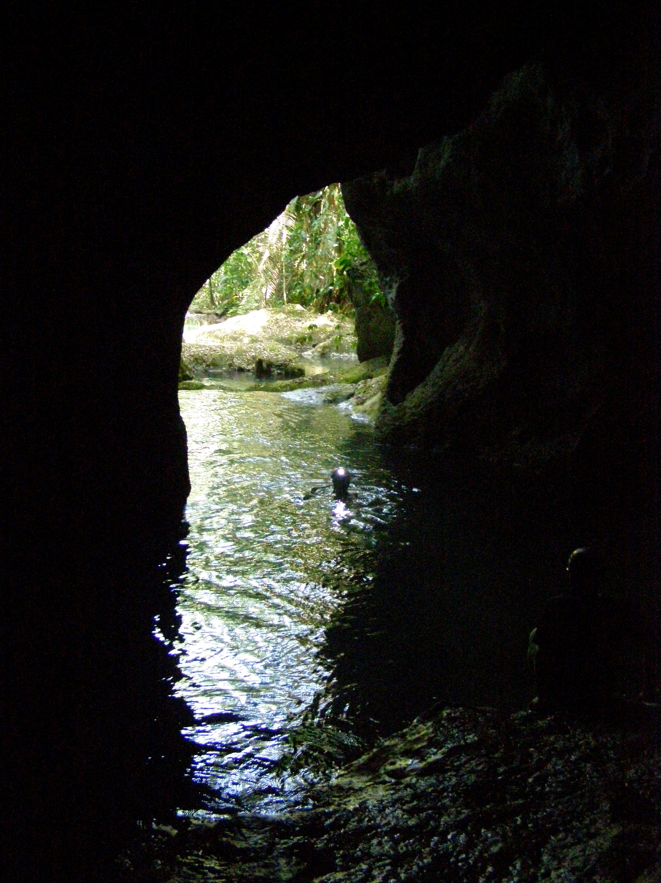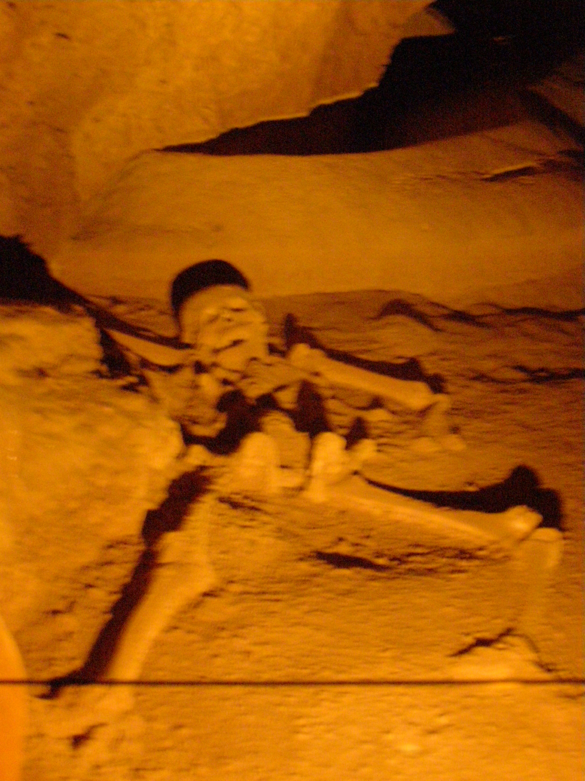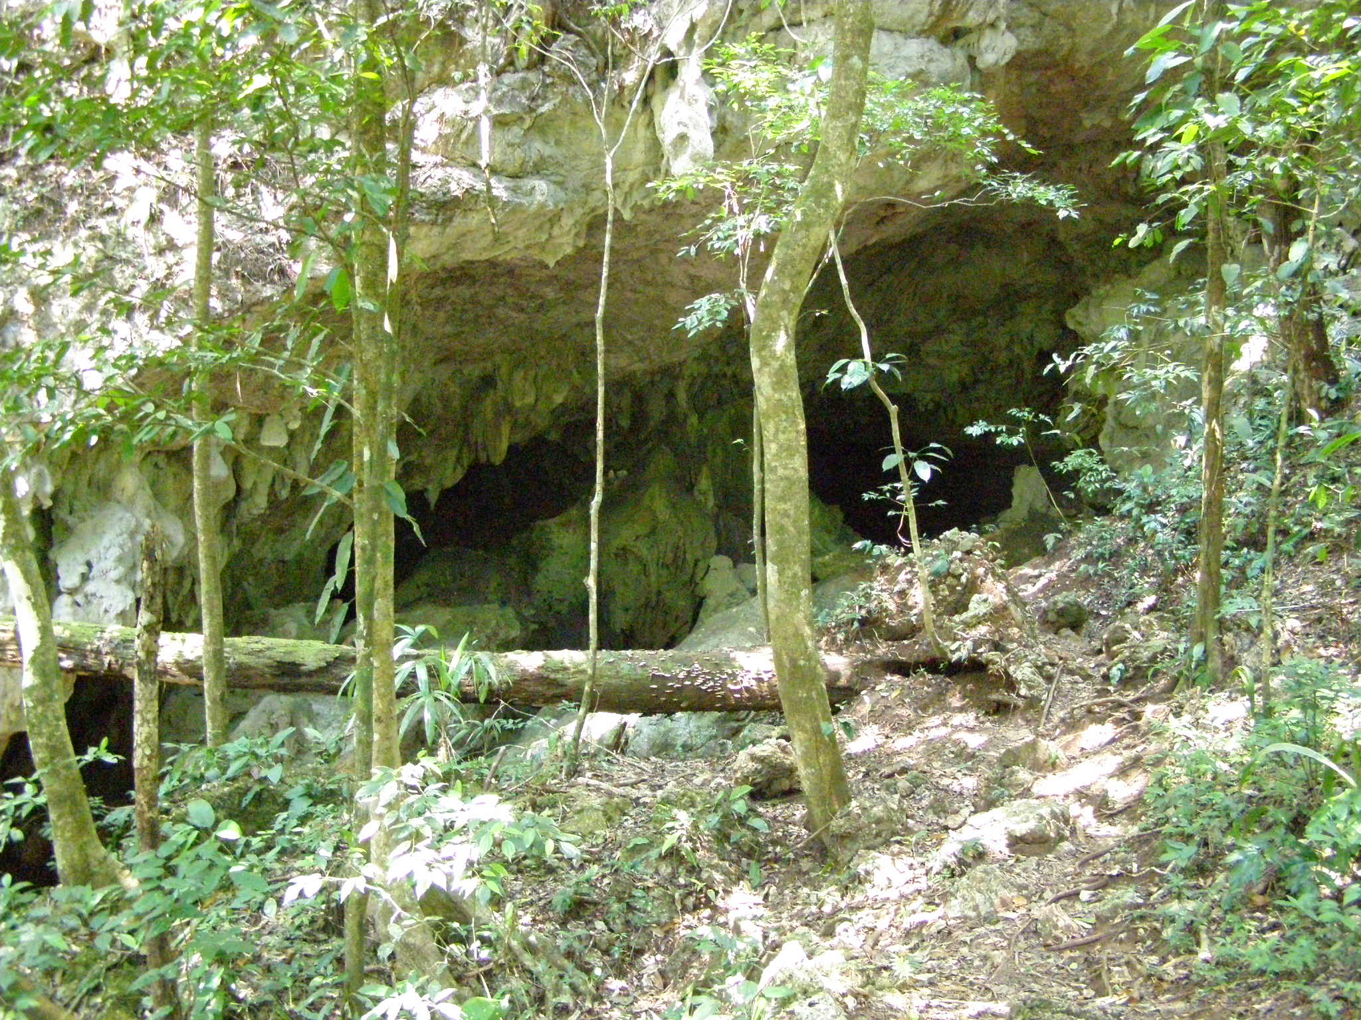
The Anniversary of my NDE
Today is my anniversary of Gratitude. Seventeen years ago,~ I took my last breath, and experienced a NDE “Near Death Experience” after contracting a parasite in the Belizean Jungle (pictures are of the cave where I got the parasite), searching for Mayan relics & history. Doctors had misdiagnosed me, after many long stays in hospitals, I found the parasite through self diagnosis~ Iridology and Energy Work. It was too late. I painstakingly sought the help of a Shaman from the Belizean Jungles, knowing that I must get a local anti parasitical from where I contracted the parasite. It took months, to find an English speaking Shaman who could send me a remedy. I weighed only 75 pounds, my oncologist gave my family two days to get my legal info in order before I would pass.

The next day, I was in my living room, alone, awake in pain. I felt as though I was floating out of my body, my deceased mother was calling me upward into a tube of white light. She looked beautiful, a fluorescent white light was caressing me- she told me the pain would be gone where we were going. I felt the pain leave my body as we went higher into the light. My mother had my hand and I was ready to go anywhere with her. I looked down beneath us and saw my crumpled dead body on the couch in my living room. I then realized I was about to cross over. I told my mother I was not ready for this~ I would like to see Kirsten & Elke (my grandchildren) grow up. She told me it was my choice~ but the pain would return and I would have to work hard at healing myself. I agreed to go back- feeling myself back on the couch in my living room, yes, back in my body. I then had a panic attack, realizing that my root chakra could not find the earth. After doing Yogic breathing I was able to calm down and relax and allow my soul to return completely and my root chakra to find the earth.
I knew I had my work cut out for me~ my lungs, heart, pancreas, kidneys, thyroid, and digestion and elimination were failing. Through self- Iridology, Energy work, lots of herbs and Yoga~ I was able to throw way the walker, depends, care takers and slowly return to my excellent state of health. My mission was to remain on the earth~ help my daughter beat her cancer and many others that I will continue to help until my last breath. It is said that one has to have a near death experience to be a Shaman or a healer~ the near-death experience has definitely made me a better healer and heightened my intuition. My insight and foresight were increased tenfold. I now give thanks every day I awaken and have a different outlook on life.
The pictures are the cave opening, inside where we had to swim in to get to an interior ledge, it was a 3-hour hike to the internal waterfall and a picture of a Mayan teenager’s skeleton that we found which was a sacrifice.
This was a trip/experience I will never forget, I have become a better "healer" through this near death experience and understand parasites much more! I appreciate every waking day of my life and everyone that has touched my life. I thank you for taking the time to read this. Rose
_______________________________________________________________________________________
How to Stop a Panic Attack: Increase ‘Traffic’ Along the Vagus Nerve
If you’ve ever experienced a panic attack, you know it’s a scary situation that can feel very out of control. In some cases, it can feel like you’re almost having an out of body experience. Because breathing and heart rate are often elevated, connecting your attention and awareness to the breath may seem counterintuitive for someone in the middle of a panic attack.
To calm clients having panic attacks, I do guided breathwork and have them first just slow their breathing down, Once they can do that, we start to extend the length of the exhale if possible.
Gently extending the exhalation helps increase “traffic” along our vagus nerve, which innervates many of our visceral organs.
There certainly are cases that don’t respond to breathwork alone. Under these circumstances, some simple movement like raising the arms up on the inhale and “floating” the arms down on the exhale.
Humming, chanting and gargling also can stop a panic attack.
Also using imagery such as asking them pick a color they like. As you inhale the color gets brighter and with the exhale it gets dimmer. Try to focus on one thing and just stay with it. This is usually quite effective.
Breathwork in yoga is known as pranayama, and different techniques can be stimulating or calming, depending on what you choose. Pranayama benefits can include stimulating your body’s “rest and digest” parasympathetic nervous system if you choose breathwork like nadi shodhana, alternative nostril breathing.
A regular hatha yoga practice, including a yoga nidra sessions, are shown to decrease anxiety levels, particularly in people who are most anxious.
Embrace a practice you can consistently fall back upon — whether it’s yoga, meditation, connecting with the outdoors — in both good times and bad is the great comfort that we humans can provide for ourselves, when we do this, we are then calm, nurtured and available to do good for others. All that good comes back full circle and makes life truly beautiful.
_______________________________________________________________________________________
_____________________________________________________________________________________
6 Impressive Health Benefits Of Maple Water
It’s time!!! Our maples are gifting maple water and many local farmers turn it into maple syrup. Let’s talk about maple water. Maple water is pure maple sap, the clear and nourishing liquid that flows from maple trees for a short time in early spring. Maple water goes through a natural process that infuses it with nutrients that have been stored in the tree all winter. Hence, not only does it taste great, maple water offers an array of health benefits.
What Is The Nutritional Value Of Maple Water?

Maple sap contains, on average, 95% to 97.5% water. Apart from sucrose which is its major sugar, the natural sap contains minerals, oligosaccharides, amino acids, organic acids, and phenolic compounds. Maple water contains 46 unique bio-active compounds, some of which have antioxidant properties. Among them, you will find minerals like potassium and zinc as well as calcium and manganese, which are good for your bones.
The plant derived compounds, such as phenolics, have immense biological effects and potential human health benefits. The mix of vitamins, nutrients, and polyphenols may even be useful in promoting thyroid and bone health along with a diabetic preventive diet. Health Benefits Of Maple Water are:

1. Good For Digestion
Maple sap is a good source of oligosaccharides and can be used as a good carbon source for the good bacteria (eg-lactobacilli) in our gut that help digest our food and strengthen our digestive system.

2. Stabilizes Blood Sugar
A new study found that maple sap contains Abscisic Acid (ABA). ABA works to help control blood sugar and is especially helpful for people with type-2 diabetes and obesity-related inflammation.
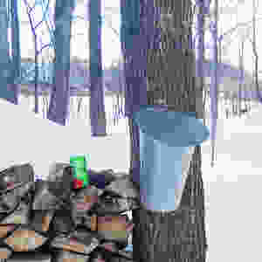

3. Potential Cancer Chemo-Preventive Effects
Polyphenols are bio-active compounds found in plant foods. Ginnalins A-C are polyphenols present in the sap and other parts of the sugar, and red maple species. Research studies show that maple polyphenols may have potential cancer chemo-preventive effects mediated through cell cycle arrest.
4. Fights Inflammatory Diseases
The Maple water contains up to 24 different antioxidants. The antioxidants, in the form of phenolic compounds in maple water, are beneficial for reducing free radical damage that can cause inflammation and contribute to the formation of various chronic diseases such as arthritis, inflammatory bowel disease or heart disease.
5. Full Of Electrolytes
Maple water also contains electrolytes, similar to coconut water. Maple water is believed to be extremely hydrating for the body and contains electrolytes such as potassium, magnesium and calcium.

6. Low In Natural Sugars And Calories
Maple water has a low calorie count of only 45cal to a 16 oz. serving, less than half the calories of other mineral waters such as coconut water. With only two percent sugar and low calorie content, maple water is a healthy alternative to sugary beverage like fruit juices or sports drinks.
How Does Maple Water Differ From Maple Syrup?
Maple water is the maple sap that flows directly from a maple tree. Maple water is not like maple syrup, although they are derived from the same place. Maple syrup is made by boiling maple sap. Since the sap contains a high water ratio, it has to undergo processing in order for the water to evaporate, leaving behind the concentrated or thick maple syrup. The concentration of maple sugar in Maple water is approximately 2%, compared to 66% concentration in maple syrup.
Though drinking maple water is considered to be beneficial, you need to make sure it is certified organic. Maple water certainly does have a lot of healthy attributes, which is one of the many reasons to drink maple water.
It is best to shop your maple syrup and honey local. Just like healing herbs should be locally resourced. For my recommendation reach out to Moran's Maple Syrup in Marilla- 716.628.8371

_________________________________________________________________________
YOGA NIDRA Meditation
Please join Rose for a very special yoga meditation class called Yoga Nidra. This is not your typical mediation~ YN opens up doorways, releases blockages, it heals every organ, bone, muscle etc, it goes DEEP in to ALL levels of consciousness, releasing scars from traumas & abuses we have suffered from in this lifetime and more. Studies have shown the benefits of Yoga Nidra to be significant at reducing effects of stress hormone cortisol, high blood pressure, addictions, aggression, ADD, ADHD, PTSD, Heart disease, asthma, diabetes, digestive conditions, ulcers, eczema, chronic pain, cancer, pre- and post-surgery, psychological challenges and much more! Your YN takes you through the veils of life, afterlife, and previous lifetimes. We experience time travel, astral projection and it's also trippy! YN has an emphasis on health and healing where habitual thinking and thought patterns are reduced or eliminated. It also helps with insomnia and stress reduction and brings an incredible calmness, quietness, clarity and is one of the deepest of all meditations.
Yoga Nidra means Yogic Sleep and is a state of conscious Deep Sleep. In this Meditation, you remain in the Waking state of consciousness, and gently focus the mind, while allowing thought patterns, emotions, sensations, and images to arise and go on. However, in this meditation, you leave the Waking state, go past the Dreaming state, and go to Deep Sleep, yet remain awake. While Yoga Nidra is a state that is very relaxing, it is also used by Yogis to purify the Samskaras (negative energy & thought patterns). It’s also great for insomniacs and those who suffer with PTSD, as well as a powerful tool for manifesting. You will have the best sleep tonight!!

The class is being held on Monday March 3rd at 7:00 PM at our studio (click here for directions). The class lasts about an hour. The fee is $15. Pre-registration is a must- call or email us for more information or reservations. Should you reserve and are unable to attend- please let us know- for there is usually a cancellation/waiting list. You may pay safely on line below, or snail mail it to the studio or drop it off if you are around.
The link to pre-pay and sign up
Body Glyphix Studio
______________________________________________________________________________________
_______________________________________________________________________________________
WINTER YOGA SCHEDULE
Times | Mon | Tue | Wed | Thu | Fri | Sat
9:30 am | Mystical  Vinyasa  Flow |  | Gentle  Healing  Yoga |  | Mystical Vinyasa  Flow
10:00 am
6:10 pm |  | Mystical Vinyasa  Flow |  | Mystical  Vinyasa  Flow

Mystical Vinyasa Flow A nice blend of Hatha & Integrative Yoga, Pilates, Somatics, fused with Reiki, blended with the wisdom of the cosmos & mysticism of Gaia ~ geared to participants needs
Gentle Healing Yoga Gentle, healing Yoga- Yoga Therapy, Somatics and Energy Medicine Yoga fused with Reiki, blended with blended with the wisdom of the cosmos & mysticism of Gaia ~ geared to participants needs
Yoga Nidra the deepest- most healing meditation on the planet- the 1st Monday of the month at 7:00 PM
Life Goes Om Free Yoga Classes to anyone with Cancer or a life-threatening disease
Class Prices $15 drop-in fee or punch card fees- 8 classes $95 or 16 classes for $165
Yoga for Sports Yoga for Golfers, Runners or Snow- Sports $85 per hour
Yoga Therapy, Chakra Toning or Private Yoga by appointment $85 per hour
(click here for directions)
"Wishing you Heaven in your heart, starlight in your soul and miracles in your life in these changing times”

PROUDLY SERVING OUR COMMUNITY
we're here to provide exceptional service
In alignment with our values here at Bodhi Glyphix, we pride ourselves in offering an exceptional customer experience. Bodhi Glyphix was established in 1984 by Rose and to this day is a heart-based business run by a spiritual female entrepreneur. When you support Rose's work on this planet you in-turn help support thousands of people worldwide to raise their consciousness and become empowered.

Rose Czyrny has given back to the community for years by offering free Yoga to folks with cancer and life-threatening diseases. She has organized clean ups for Earth day, offers free Yoga once a year to schools and seniors.
The Bodhi Glyphix Studio
Rose Czyrny
12377 Big Tree Road, East Aurora, NY 14052
email: bodyglyp@msn.com
website: www.bodyglyphix.com
phone: 716.652.7805

