June 27th, 2023 Issue #210 The Iris The Bodhi Glyphix Studio

Greetings!

Thank You for allowing us into your world! Welcome to our monthly newsletter! Please feel free to share this via email or social media. If you no longer wish to receive to receive our newsletters, plz scroll down to the bottom and unsubscribe.
Welcome Summer! Astrologically & environmentally speaking, we have had quite a bit of action in our skies. Solar flare ups, retrogrades, high pollen counts and smoke from Canadian fires. Hoping that your respiratory tracks are not compromised and toxins/smoke didn’t affect your health. I had to be outdoors for the 3 days or so of air quality alerts. In the evening, my hair and nasal passages (when rinsed) the water was gray, of course I did a detox for a few weeks. If you would like my help, with a detox or to support your lungs, send me a message.
______________________________________________________________________________________
Attention Yoginis!
Beginning in September 1st….
Yoga prices are going to slightly increase, drop in fee will be $15 and our discounted punch cards still the best deal for your $$ at 16 pack is going to be $165 and our popular 8 pack will be $95. Our punch cards have always had 3 month life span, or 12 weeks to use it up. During covid I did extend the expiration date to 6 months as everyone was getting sick. The covid pandemic is no longer an issue, we are back to the 3 month expire date. If you become sick, injured or away for some time, please let me know and I will extend the punch card for you. If I do not know, the card is pulled from the basket and considered expired and no longer usable. Always keep me in the know. I did hold back on this increase for 2 years and will continue to give you our best service and prices.
_______________________________________________________________________________________
OUR STUDIO WILL BE CLOSED
For a week
Bodhi Glyphix will be closed Friday, July 1st Through Friday, July 8th. Should you need supplements or any advice? Please reach out to mes before then. Roll out your yoga mat, if you some structured yoga, I have a You Tube channel. It’s $13 to tune in and get your dose of Yoga. Here’s the link to 40 videos made during the pandemic. There are one or 2 with no sound. Let me know and I can refund you the $13, it was the first few videos and I was new to video taping. https://www.youtube.com/channel/UCN_mttLrqw1KBNC6TdQl50Q
_______________________________________________________________________________________
This photo is FB 7
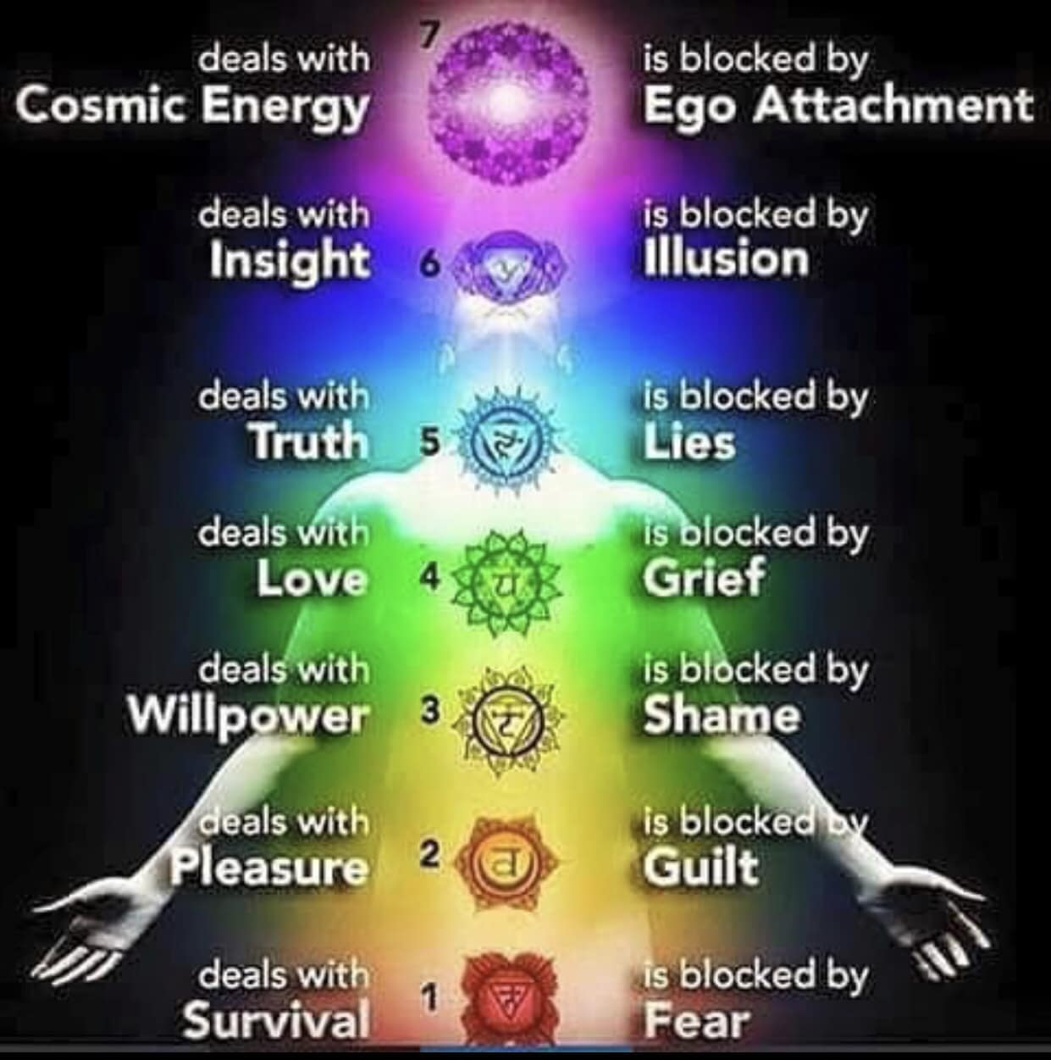
______________________________________________________________________________________
X39 The Holy Grail of Health

First~ please let me share my many stories. Many of you know I injured my knee pretty bad when I fell in Valu Hardware a few years ago. Well, I re-injured it again, and again... I put a patch right on my knee and within 24 hours it was better!! A year and half ago I hurt my back, blew out 5 disks, and rupturing three. Now, anytime I overdo it, or need a powerful healing modality, I cannot allow the studio to close~ I place one on a generic acupressure spot or directly on the area needing help, and it helps by making stem cells for rapid healing.
I also have clients that could barely walk, spinal problems, knee issues etc. One woman did the patches for 4 months and was walking and swimming again. Another woman after many cervical spine surgeries and years of pain and inflammation, was able to come off her opiates and pain medications.
Now please let me tell you about these patches. LifeWave X39 is a patented phototherapy is designed to elevate a peptide known to enhance stem cell activity, clinically shown to elevate the naturally occurring copper peptide GHK-Cu, which is known to decline with age. When Copper HGK-Cu is elevated in the body, this peptide activates the bodies stem cells. This may provide incredible benefits such as:
⁕Rapid Pain Relief ⁕Mental Clarity
⁕Faster Recovery from Exercise ⁕Improved Sin Appearance
⁕Improved Energy & Vitality ⁕Supported Wound Healing
⁕Reduced Inflammation ⁕Better Sleep
How to wear them:

Place a new X39 patch 3 finger widths below your belly button, or on the GV14 acupressure point on the back of your neck. Locate by putting your chin into the hollow of your throat and you will notice 2 vertebrae protruding at the bottom of the neck. The GV 14 point is on the 2 vertebrae.

Wear the patch every day or night for 12 hours per day.

Remove the patch for 12 hours, if left on too long your body can get used to the stimulation of the patch and begin to ignore it. All bodily functions work on cycles, just like the need for sleep. So to have the maximum effectiveness, there should be 12 hours of a ”rest” period. Should you forget and leave it on for 24 hours, remove the patch and wait at least 8 hours to start the daily usage again.

It is not necessary to put the patch directly on the pain or affected area~ but you may do so if you wish. Wearing it on the directed spots (below the navel or back of the neck) will positively affect the whole body. They do lose their efficiency after being worn on or near the body for more than 24 hours. Be sure to change them daily. They are also heat activated, so keep them away from heat, or do not carry them in a pocket.

How long before I see results?
Everyone is different. Some people get immediate results, but not everybody! Your body heals and regenerates on a priority basis. Your body knows what needs to be healed first, which you may not be aware of. Trust the natural healing order of the body. I like to suggest take a note book, jot dates and take notes so you can see your progress.
We recommend wearing them for 6 months even if you do not see an improvement right away. Stay consistent, most people notice ongoing improvement in health over time.

Some tips to help:
Stay Hydrated! Drink a large glass of water before applying the patch and continue to drink water through out the day. Take your body weight divide it by two, that is close to how many ounces you should drink daily, max is 90 ounces.
Mild Detox Symptoms~ it’s called a healing crisis. Symptoms of a headache, nausea or fatigue, drink plenty of water and the symptoms should go away. If they don’t, take the patch off and reapply it after 12 hours. Or try LifeWave’s Glutathione Patches to support the detox and decrease the detox symptoms.
Supplement with trace minerals in pink or gray sea salt, Nature’s Sunshine’s Mineral Chi Liquid works great too.

Eat Healthy meats and fats such as rainbow trout, salmon, sardines, whole eggs, coconut oil, full fat yogurt, walnuts, olives and grass-fed beef.

Eat More food rich in copper~ liver, oysters, kales, goat cheese, shitake mushrooms, chick peas, dark chocolate, sunflower and/or sesame seeds, almonds, cashews avocado and asparagus.

Take before and after photos, journal your days in a notebook, check out GHK-Cu Wikipedia page, do a google search, supplements and injections are not approved at this time.

You get 30 patches in the kit and…. Rose’s help with a purchase from the link or at the studio. If yo order them yourself you can save $50, reach out to us for how to do this.
When you order form the link~ there is a 90-day hassle-free trial!
For first-time LifeWave customers we offer an Initial Order MBG money back guarantee. This policy makes it possible for new customers to try out products 100% risk-free and hassle-free for a full 90 days; no need to return empty sleeves or unused product. Only a customer’s first-ever order is eligible.
Not a first-time buyer?
You can still return resaleable product within 30 days of purchase date for a full refund..

To check out the patches or to order~ you may go to www.lifewwave.com/bodyglyp or message via email or check them out at the studio
_______________________________________________
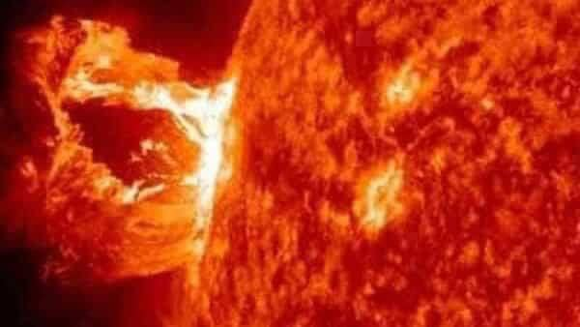
The Skinny on Solar Flare Ups
Intense solar flares can eject out huge amounts of solar material including radiation- called a coronal mass ejection (CME), which can fling out vast clouds of solar plasma away from the sun at speeds of up to 1 million mph. When aimed directly at Earth, the strongest solar flares and CMEs can interfere with communication systems, power stations and satellites.
If there is an explosion in the Sun, it may not come from a sunspot. Unstable magnetic filaments can pose the greater threat. Unstable solar filaments are twisted tubes of magnetism filled with dense plasma. These eruptions can hurl massive CMEs into space - and towards Earth if Earth-facing.
Solar flares are like cyclones or hurricanes on the Sun that emit intense amounts of energy, which can be directed towards Earth if Earth-facing at time of eruption. The Sun’s electromagnetic energy directly affects our body, mind and emotions. That’s because our bodies also emit electromagnetic frequencies, primarily from our heart and brain.
Solar flares and solar storms can affect us, especially people sensitive to energies. Symptoms may include chronic fatigue, aches and pains, tension headache, persistent head pressure, migraines, ringing in the ears, throat issues, toothaches, sore back, nausea, dizziness, itchiness, difficulty maintaining balance, feeling ‘spaced out’, becoming more aware, becoming aware of other dimensions, losing track of time, overwhelming emotions, agitation, restlessness, apprehension, anxiety, mood swings, feeling irritable, anger, depression, shaking, lethargy, tiredness, sleep disturbance / insomnia, vivid dreams, forgetfulness, feel ‘off’ or ‘foggy headed’, heart palpitations, short term memory issues and inability to concentrate. Also, one may experience trouble with wireless technology or may have inspiration coming forward at random times.
Solar storms are known to affect our pineal gland and desynchronise our circadian rhythm (our internal biological clock that controls our sleep and wake times). When solar winds interact with Earth’s electromagnetic field, it temporarily disturbs the magnetosphere. When Earth’s electromagnetic field is pushed and pulled by solar energy, our own electromagnetic field (our Auric field) senses the magnetic force and is also pushed and pulled. Solar flares affect our body’s Central Nervous System, all brain activity (including equilibrium), human behaviour and all psycho-physiological (mental-emotional-physical) response. At the DNA level, these solar flares are helping us awaken the hidden treasures within our dormant (galactic) DNA.
For those that are affected, you may find aromatherapy, sea salt baths or showers, drinking lots of water, reduce your caffeine intake, doing meditation and/or exercise as well as grounding to be of some help. Release negative energy. Ground yourself by walking in nature, meditating outdoors. Be gentle with yourself. Hydration and electrolytes are vital. Distance yourself from negative people.
During intensive energy shifts, it is highly recommended to regularly cleanse your energy field at the start and end of each day by meditating. Taking sea salt water baths or showers, eating light high vibrational foods, avoiding caffeine and alcohol, reducing the amount of time spent on technology, resting as much as you can, staying away from environments that feel toxic and draining, grounding yourself in nature, and when possible, spending periods of time alone.
___________________________________________________________________________
SACRED HERBAL DEFUMATION
• Burn orange peels, to attract joy
• Burn thyme, to attract money
• Burn coriander, to attract loyalty
• Burn white sage, to purify and renew energy
• Burn sunflower seeds and sugar, to bring abundance
• Burn artemisia, to have vision and lucid dreams
• Burn coffee, to scare eguns
• Burn rosemary, to remove diseases caused by viruses and bacteria
• Burn lavender, for calm and tranquility
• Burn chamomile, to remove spells and bring luck
• Burn peppermint, to calm your thoughts
• Burn blonde, to end anxiety and protect against spells
• Burn carnation, to avoid gossip, to attract luck, money and good friendships
• Burn cinnamon, to spice up the relationship and attract saturation
• Burn garlic husk, to ward off envy.
• Burn white rose, to bring harmony and sweetness
• Burn tobacco, to expel evil spirits
• Burn Palo Santo, to purify and protect
• Burn star rings, to ward off evil eye, bring protection and good luck
• Burn it wrinkle, to break curses
• Burn tangerine shells, to attract new love
• Burn oak bark, for fertility
• Burn lemon grass, to energize talismans
• Burn eucalyptus leaves, to keep bad people away
• Burn Guinea, to get jobs and make dreams come true
• Burn violet petals, to heal a broken heart
Note: use dry (dehydrated) herbs to make smokes.
Author Unknown
__________________________________________________________________________________
Yoga Nidra Meditation
There will be no Yoga Nidra Meditation for July as our studio will be closed July 1st through the 8th. See you all in August for the most healing meditation ever.
___________________________________________________________________
SUMMER YOGA SCHEDULE

Times | Mon | Tue | Wed | Thu | Fri | Sat
9:30 am | Mystical  Vinyasa  Flow |  | Gentle  Healing  Yoga |  | Mystical Vinyasa  Flow
6:10 pm |  | Mystical  Vinyasa  Flow |  | Mystical  Vinyasa  Flow

Mystical Vinyasa Flow A nice blend of Hatha & Integrative Yoga, Pilates, Somatics, fused with Reiki, blended with the wisdom of the cosmos & mysticism of Gaia ~ geared to participants needs
Gentle Healing Yoga Gentle, healing Yoga- Yoga Therapy, Somatics and Energy Medicine Yoga fused with Reiki, blended with blended with the wisdom of the cosmos & mysticism of Gaia ~ geared to participants needs
Yoga Nidra The deepest- most healing meditation on the planet- the 1st Monday of the month at 7:00 PM
Life Goes Om Free Yoga Classes to anyone with Cancer or a life threatening disease
Class Prices $13 drop in fee or punch card fees- 8 classes $88 or 16 classes for $155
Yoga for Sports Yoga for Golfers, Runners or Snow- Sports $85 per hour
Yoga Therapy, Chakra Toning or Private Yoga by appointment $85 per hour (click here for directions)

______________________________________________________________________________________

"Wishing you Heaven in your heart,
starlight in your soul and miracles in your life in these changing times”
The vibrational rate of our planet is quickening
Our bodies must make the vibrational change with the planet
Find down time, practice Yoga & Meditation

The Bodhi Glyphix Studio
Rose Czyrny
12377 Big Tree Road
East Aurora, NY 14052
email: bodyglyp@msn.com
website: www.bodyglyphix.com
716.652.7805

