November 22nd, 2023 Issue #215 The Iris The Bodhi Glyphix Studio

Greetings!
Happy Thanksgiving from the Bodhi Glyphix Studio!! Please enjoy our latest newsletter! November is the month of gratitude (let’s open the front door of our Heart Chakras) as we share this time of “thankfulness” with friends and family. It’s also a time to remember our ancestors who came to this land and endured great hardship for us. We all have so much to be thankful for.
I would like to express my gratitude to you for your support and commitment to a healthy, active, sustainable lifestyle. You’re the reason we have been able to make a difference in the community and it’s for you that we strive to find new and innovative solutions to help you with your wellness goals.

“Travel light, live light, be the light & Spread the light”

Inclement Weather~ Studio Closings
As we get into winter months, living in Western NY often brings weather with hazardous travel conditions. When the weather is inclement, and you are wondering if we are closed, if our internet/phone is up and running, you will receive an email. If we do not have a phone/internet connection, check channel 7 and 2 for closing status. We would like you to be safe, when in doubt look for that email, or check Channel 7 or 2. Route 20A is kept clear, but look for our closing status, stay home and find the comfort in stillness, meditate or do some Yoga.
___________________________________________________________________________
MOXIBUSTION~ The Alternative to the Flu Shot
Exclusively at our Studio
Available Monday, Wednesday & Friday at 11 AM
Tuesday & Thursdays at 7:30 PM
This is the 18th year our humble Studio has offered this little known modality. I believe we are the only Studio in all of upstate NY to offer this technique. Moxibustion is a homeopathic remedy using Artemis Vulgaris which is used as a warming agent of the meridian associated with the immune, effective against ALL strains of influenza (except- the stomach flu which is not a true flu). Our effectiveness against all influenza is around 99% as well as 85% against other viruses. Moxi is a 2-minute procedure. It has been documented that this year’s medicinal Flu Vaccine is what’s left over from last year, the drift collaborated from last year’s influenza. Educated people know that the strains that affect us morph/change every 10 days. You cannot use the drift from last year to prevent this year’s viruses! Viruses evolve/morph every 10 days- constantly changing.

The fee for this exclusive procedure is $20- we do have great family and group discounts. From newborn babies to seniors- this technique is for everyone. We can come to your office or your home as well. For more information or to schedule an appointment call or email Rose. For additional suggestions- please also see the article below for Cold & Flu Prevention.
How does moxibustion work? Does it hurt?
There are two types of moxibustion: direct and indirect. In direct moxibustion, a small, cone-shaped amount of moxa is placed on top of an acupuncture point and burned. This type of moxibustion is further categorized into two types: scarring and non-scarring. With scarring moxibustion, the moxa is placed on a point, ignited, and allowed to remain onto the point until it burns out completely. This may lead to localized scarring, blisters and scarring after healing. With non-scarring moxibustion, the moxa is placed on the point and lit, but is extinguished or removed before it burns the skin. The patient will experience a pleasant heating sensation that penetrates deep into the skin, but should not experience any pain, blistering or scarring unless the moxa is left in place for too long. We do NOT use either of these techniques.
Indirect moxibustion is currently the more popular form of care because there is a much lower risk of pain or burning. In indirect moxibustion, a practitioner lights one end of a moxa stick, roughly the shape and size of a cigar, and holds it close to the area being treated for several minutes until the area turns red. Another form of indirect moxibustion uses both acupuncture needles and moxa. A needle is inserted into an acupoint and retained. The tip of the needle is then wrapped in moxa and ignited, generating heat to the point and the surrounding area. After the desired effect is achieved, the moxa is extinguished and the needle(s) removed. We do NOT use needles for this- just an indirect warming of your skin on the appropriate meridian.
What is moxibustion used for?
In traditional Chinese medicine, moxibustion is used on people who have a cold or stagnant condition. The burning of moxa is believed to expel cold and warm the meridians, which leads to smoother flow of blood and qi. In Western medicine, moxibustion has successfully been used to turn breech babies into a normal head-down position prior to childbirth. A landmark study published in the Journal of the American Medical Association in 1998 found that up to 75% of women suffering from breech presentations before childbirth had fetuses that rotated to the normal position after receiving moxibustion at an acupuncture point on the Bladder meridian. Other studies have shown that moxibustion increases the movement of the fetus in pregnant women, and may reduce the symptoms of menstrual cramps when used in conjunction with traditional acupuncture. Moxibustion is also used for many other purposes in conjunction with acupressure and acupuncture. It was discovered that the clients who received this application did not get influenza 40 years ago and forward.
At our Studio we use indirect moxibustion (without needles) to warm the skin and the meridians directly responding to the immune. The technique is quick and virtually painless. We also recommend taking Vitamin D3 supplements, Silver Sol (we carry this priced way below suggested retail price), washing hands frequently and avoid touching your face. Set up your appointment today. It literally takes a minute!
_________________________________________________________________________
Help with Sinus Problems!

Most of us living in WNY have them- whether we like it or not. You know- Sinus infections, head colds- whatever you want to call it. The first line of defense should you feel a head cold or sinuses coming on is to avoid sugar, wheat, dairy and alcohol. Sugar, wheat and alcohol make viruses and bacteria multiply. Dairy creates mucous and congestion. A 24 hour fast is highly recommended- most of us can safely fast for 24 hours, water/herbal teas/unsweetened juice, or bone broth fast. Make sure that you are hydrated~ 6-8 glasses of filtered water. Doing a Colon and Liver Detox (we carry a good supply at our Studio) extremely important- even better if you can do this during a fast. Following this protocol- you just may catch it just before it gets out of hand. Nature’s Sunshine’s Seasonal Allergies is an effective supplement to heal the respiratory track. Read the article below to see more on this amazing product. Their Olive Leaf will kill any bacteria and/or viruses. So does the Silver Biotics that I recommend you have already stocked up on.
If this doesn’t work and you do get sick- I have been VERY successful helping my clients with our Silver Biotics. This is not the same as Colloidal Silver. It is suspended in a solution making it much lighter and more effective at killing bacteria, fungi and viruses. We always have it in stock at the Studio. I recommend 1 tsp/tblsp 3 times per day orally. Take the Silver Biotics nasally too. We now carry a triple strength Silver that is necessary to get the nasty virus that is going around. Whether you use a little in your Neti Pot or dropper or just sniff it from the cap. It can go in your humidifier or nebulizer also. In tough cases- I like to add either Myrrh, Goldenseal, Oregano, Grapefruit Seed Extract or Olive Leaf (orally) - also sold in our Studio. It may sound cliché- but we only sell the best, if we sell products that do not work- you will not come back or recommend me. Should you get sick- give us call or an email. We have what you need during cold and flu season. We have a large selection of detoxes at our Studio also.
I have made it a practice, in the 45 years that I have been in business and helping people with their wellness goals- I only endorse products, services and programs that historically work, that I truly believe in, from providers I know and trust. That have also been tested, case studied or a stamp of approval from the top Naturopathic doctors or holistic practitioners in the US. Don’t forget to neti pot!!
_________________________________________________________________________
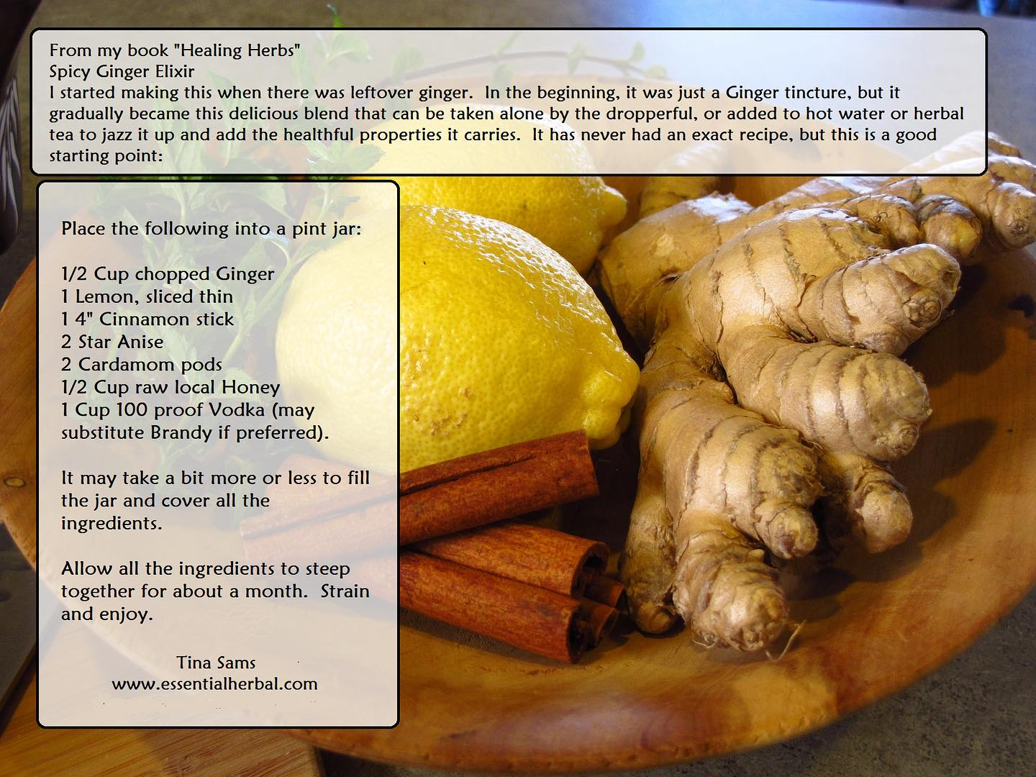
__________________________________________________________________________________
FB pic is pain
"Grandma how do you deal with pain?"
"With your hands, dear.
"When you do it with your mind, the pain hardens even more."
“With your hands, grandma?"
"Yes, yes.
Our hands are the antennas of our Soul.
When you move them by sewing, cooking, painting, touching the earth or sinking them into the earth, they send signals of caring to the deepest part of you and your Soul calms down.
This way she doesn't have to send pain anymore to show it.”
"Are hands really that important?"
"Yes my girl.
Think of babies: they get to know the world thanks to their touch.
When you look at the hands of older people, they tell more about their lives than any other part of the body.
Everything that is made by hand, so it is said, is made with the heart because it really is like this: hands and heart are connected.
Think of lovers: When their hands touch, they love each other in the most sublime way.”
"My hands grandma... how long since I used them like that!"
Move them my love, start creating with them and everything in you will move.
The pain will not pass away.
But it will be the best masterpiece.
And it won't hurt as much anymore, because you managed to embroider your Essence.
Elena Barnabé
___________________________________________________________________________________
Depression and the Holidays
Connecting to your Heart Center
|
There is a concept in Chinese Medicine called Shen. Your Shen resides in your heart, it can be described as the part of you which connects with your heart and spirit, or higher self. When Shen is depleted, we feel depressed and lack inspiration. It becomes hard to accomplish even simple tasks, because we don’t seem to care about anything. When your Shen is depleted, you feel disconnected from life, there may be an emptiness in your eyes, and a lack of peace in your life. You may suffer from sleep disturbances, patterns of stress, anxiety, or agitation. Imbalances of Shen can result in mental cloudiness, loss of memory and a lack of ability to maintain focus.

We connect with our Shen though our heart center. Think of the expression “follow your heart” verses being led by your logical mind. Our Shen gets depleted when we push ourselves to a point where we are just going through the motions of life. We deplete our Shen when we do not take time to go into our heart to rekindle our Spirit, connect with our Creator and quiet our mind. In addition, anything that “upsets the heart” can deplete Shen. Trauma, arguments, emotional struggles, or overuse of alcohol and drugs – even prescription drugs, if they cause you to feel disconnected from yourself.

In addition, you may notice the following:
Life feels off balance; your personality does not fit the life you are living.
There is a lack of inspiration and meaning to your life.
You feel like you have lost yourself, don’t know who you really are anymore. You have no sense of purpose.
You may have a lot of things going on around you, but you can’t find your center, so this leads to anxiety, restlessness, and eventually, fatigue.
You can no longer tell what is truly right for you.
Chinese Mood Elevator formula – is a combination of herbs traditionally used in Chinese medicine to help restore your connection with Shen to help increase vitality and promote a greater sense of well-being. This formula also helps to “calm the spirit and quiet the heart”. The herbs in this formula also work to gently cleanse the liver which helps to improve the flow of “Chi” (life force energy) throughout the body, which helps to lift the moods. The herbs in this formula promote healthy digestive functions, help the body to release pain and inflammation.

As your connection with Shen and the flow of Chi (life force energy) returns you will feel a shift in your perspective. It’s like the “birds are singing” again. Life begins to have more meaning and purpose, you feel whole, more complete. Your sleep is more restful. As you build your Shen you will focus more on the things that are important to you. You have a desire to align your life with your heart’s inner callings, you seek your Soul purpose. As you build your Shen your intuition activates, you have greater insights on your life choices and directions. Your eyes will have a brightness return to them and your mind will become clearer.
I have used this excellent Nature’s Sunshine product to get me through a period this year of heavy grief, it can help with anxiety, depression, menopausal issues and many issues of the heart. I used Mood Elevator TCM, a concentrated version, taking less. Interested in ordering this? Make sure you are taking D3 also! 5000 IU’ daily, the main reason we suffer with the above. To order~ call them 1-800-223-8225 and tell them Body Glyphix (my acct # 9191) said to call, for my wholesale prices!! Rose
_______________________________________________________________________________________

What’s on Their/Your Holiday list?

It’s time to think about the upcoming Holidays. What’s on your holiday list? Perhaps a Yoga Pass Card? A Body, Mind & Soul Consultation? Or maybe you are thinking for someone that has everything? A private Yoga Session? Clearing their/your house or business of negative energies? Chakra Toning Session with Crystals? Or our products? When they ask this season- tell them what you want! Or maybe there’s someone that could benefit with the gift of health. We have gift certificates for any dollar amount! You may purchase them on my secure website www.bodyglyphix.com/giftcertificates.com or pick them up at the Studio~ anytime……
_______________________________________________________________________________________
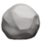𝐌𝐢𝐧𝐞𝐫𝐚𝐥𝐬: 𝐓𝐡𝐞 𝐁𝐮𝐢𝐥𝐝𝐢𝐧𝐠 𝐁𝐥𝐨𝐜𝐤𝐬 𝐨𝐟 𝐇𝐞𝐚𝐥𝐭𝐡 
Minerals are essential micronutrients that play a vital role in maintaining our overall health and well-being. They come from various natural sources and are crucial for numerous bodily functions. In this post, we'll delve into where minerals originate, their significance in our bodies, the consequences of mineral deficiencies, and how to ensure you're getting an adequate supply.
Minerals are found in both organic and inorganic sources. They originate from the earth's soil, water, and geological processes. Plants absorb minerals from the soil, and animals obtain them by consuming plants or other animals. Inorganic sources include mineral-rich rocks and deposits.
Minerals are involved in a wide range of physiological processes. Here are some examples of their functions:
𝑪𝒂𝒍𝒄𝒊𝒖𝒎: Vital for bone and teeth formation, muscle contraction, and blood clotting.
𝑰𝒓𝒐𝒏: Essential for transporting oxygen in red blood cells.
𝑷𝒐𝒕𝒂𝒔𝒔𝒊𝒖𝒎: Regulates heart rhythm, muscle contractions, and fluid balance.
𝙈𝙖𝙜𝙣𝙚𝙨𝙞𝙪𝙢: Supports muscle and nerve function, bone health, and energy production.
𝒁𝒊𝒏𝒄: Aids in immune function, wound healing, and DNA synthesis.
𝑺𝒐𝒅𝒊𝒖𝒎: Maintains fluid balance, nerve function, and blood pressure.
When your body lacks essential minerals, it can lead to various health issues. For instance:
𝘾𝙖𝙡𝙘𝙞𝙪𝙢 𝘿𝙚𝙛𝙞𝙘𝙞𝙚𝙣𝙘𝙮 : Weak bones, teeth problems, and muscle cramps.
𝙄𝙧𝙤𝙣 𝘿𝙚𝙛𝙞𝙘𝙞𝙚𝙣𝙘𝙮 : Fatigue, anemia, and reduced cognitive function.
𝙋𝙤𝙩𝙖𝙨𝙨𝙞𝙪𝙢 𝘿𝙚𝙛𝙞𝙘𝙞𝙚𝙣𝙘𝙮 : Muscle weakness and irregular heartbeat.
𝙈𝙖𝙜𝙣𝙚𝙨𝙞𝙪𝙢 𝘿𝙚𝙛𝙞𝙘𝙞𝙚𝙣𝙘𝙮 : Muscle spasms, tremors, and fatigue.
𝙕𝙞𝙣𝙘 𝘿𝙚𝙛𝙞𝙘𝙞𝙚𝙣𝙘𝙮 : Weakened immune system and delayed wound healing.
𝙎𝙤𝙙𝙞𝙪𝙢 𝘿𝙚𝙛𝙞𝙘𝙞𝙚𝙣𝙘𝙮 : Muscle cramps, low blood pressure, and dehydration.
A well balanced diet will provide many essential minerals. However, minerals in food are dependent upon the minerals in the soil, which unfortunately have been depleting drastically over time due to modern agricultural practices. Which means supplementation has become necessary.
If you are concerned about mineral deficiencies, let’s chat and get you the correct supplement routine for your body.
Your body will thank you for providing it with these essential building blocks of health. 
___________________________________________________________________________
Yoga Nidra~ Meditation
Please join Yogini Rose for this VERY special mediation~ YN opens up doorways, releases blockages, it heals every organ, bone, muscle etc, it goes DEEP in to ALL levels of consciousness, releasing scars from traumas & abuses we have suffered from in this lifetime and more. Your YN takes you through the veils of life, afterlife, and previous lifetimes. We experience time travel, astral projection and it's also trippy! YN has an emphasis on health and healing where habitual thinking and thought patterns are reduced or eliminated. It also helps with insomnia and stress reduction and brings an incredible calmness, quietness, clarity and is one of the deepest of all meditations.
This meditation has a special emphasis on health and healing where habitual thinking and thought patterns are reduced or eliminated and it also helps with insomnia and stress reduction. It also brings an incredible calmness, quietness, clarity and is one of the deepest of all meditations. Yoga Nidra means Yogic Sleep and is a state of conscious Deep Sleep. In this Meditation, you remain in the Waking state of consciousness, and gently focus the mind, while allowing thought patterns, emotions, sensations, and images to arise and go on. However, in this meditation, you leave the Waking state, go past the Dreaming state, and go to Deep Sleep, yet remain awake. While Yoga Nidra is a state that is very relaxing, it is also used by Yogis to purify the Samskaras (negative energy & thought patterns). YN is also powerful tool for manifesting. It’s also great for insomniacs and those who suffer with PTSD.

The class is being held on Monday December 4th at 7:00 PM at our studio (click here for directions). The class lasts about 50 minutes. The fee is $15 at the studio. Pre-pay & registration is a must- to pre-register go to http://www.bodyglyphix.com/upcomingclassesevents.html if the pay link is removed, the class is full. Paying for the meditation on line is $17 to cover our costs for the transaction.

If the payment window is gone, and sold out is at the top on the link on the website, we are full!!! Check back early next month! Or ask to be put on our last minute cancellation list.

WINTER YOGA SCHEDULE
Times | Mon | Tue | Wed | Thu | Fri | Sat
9:30 am | Mystical  Vinyasa  Flow |  | Gentle  Healing  Yoga |  | Mystical Vinyasa  Flow
6:10 pm |  | Mystical Vinyasa  Flow |  | Mystical  Vinyasa  Flow

Mystical Vinyasa Flow A nice blend of Hatha, Integrative, Pilates & Foot Reflexology fused with Reiki, blended with the wisdom of the cosmos & mysticism of Gaia ~ geared to participants needs
Mystical Vinyasa Flow A nice blend of Hatha & Integrative Yoga, Pilates, Somatics, fused with Reiki, blended with the wisdom of the cosmos & mysticism of Gaia ~ geared to participants needs
Gentle Healing Yoga Gentle, healing Yoga- Yoga Therapy, Somatics and Energy Medicine Yoga fused with Reiki, blended with blended with the wisdom of the cosmos & mysticism of Gaia ~ geared to participants needs
Life Goes Om Free Yoga Classes to anyone with Cancer or a life threatening disease
Class Prices $15 drop in fee or punch card fees- 8 classes $95 or 16 classes for $165
Yoga for Sports Yoga for Golfers, Runners or Snow- Sports $85 per hour
Yoga Therapy, Chakra Toning or Private Yoga by appointment $85 per hour

"Wishing you Heaven in your heart, starlight in your soul and miracles in your life in these changing times" The vibrational rate of our planet is quickening- the vibrations have a dominant masculine force Our bodies must make the vibrational change with the planet.
Yoga and meditation are very helpful with this transition….

The Bodhi Glyphix Studio
Rose Czyrny
12377 Big Tree Road, East Aurora, NY 14052
email: bodyglyp@msn.com
website: www.bodyglyphix.com
716.652.7805

