December 23, 2023 Issue #216The Iris The Bodhi Glyphix Studio

Greetings!

Heart-felt Holiday Wishes from us to you and yours! With the Winter Solstice behind us~ we celebrate the return of our Sun!!! And much Gratitude for each and every one of you for your support this past year. Coming off of the Winter Solstice and heading into a time of root foods and root feelings, dig deep into your sub-conscious and let’s begin to think and live in the 5th dimension. It’s a place where you look at everything from the heart and our energetic bodies. These shifts have affected our DNA & RNA- we are entering the Age of Aquarius. The change is coming in like waves… Ride the waves, let’s be more like the water element as we bring in 2024.

Holiday Yoga Schedule

Welcome new Yoginis and old to any class, no need to call or email, just show up! Wear something comfortable, loose fitting. We have Yoga mats, you don’t need to bring one. Bring an open heart and mind. Be prepared to lose stress, anxiety, depression, tension and tightness from your body. Join Rose at any class and feel the healing power of Yoga. Drop in is $15 per class. Come as often or as little as your schedule permits. Scan down to the bottom for our schedule. We will be closed Monday 12/25 Monday 1/1/24.

Read on for the MANY benefits of Yoga below!!!
______________________________________________________________________________________
Inclement Weather~ Studio Closings
As we head into winter, living in Western NY often brings weather with hazardous travel conditions. When the weather is inclement, and you are wondering if we are closed, if our internet/phone is up and running, you will receive an email. If we do not have a phone/internet connection, check channel 7 and 2 for closing status. We would like you to be safe, when in doubt look for that email, or check Channel 7 or 2. Route 20A is kept clear, but look for our closing status, stay home and find the comfort in stillness, meditate or do some Yoga.
_______________________________________________________________________________________
The Snow Walking & Cold Water Immersion
(Snow Thermogenesis/Cryotherapy)
This healing modality can help you on soooo many levels! before you head out in the snow- have a bottle of warm water with you, a dry towel and shoes you may slip on when you have had enough. Here's some tips on walking in the snow:
So, how do I train for bare foot snow walking?
The most important thing to remember is that you are asking your body to adapt, so it will happen slowly and at your own body’s pace. Get your ego out of the picture, and decide to think of this as a long-term project.
The second thing to do is establish a regular outdoor cold walking schedule. For me, I take my dog out each morning and roll up my yoga pants and I do have a coat on. I attempt to stay out for about 2 to 10 minutes per session. If you are new, start with a minute or less. Breathe! Focus on your exhale. Allow yourself to feel the pain that comes with extremity training. When it hurts, go inside and warm your feet. You may use your hands or room-temperature water if you want. It’s not cheating.
Do this daily, and try to focus on your feet when they get cold. Focus on the pain, and don’t ignore it. We are learning to listen to our body. If your feet go numb while doing this, you have waited too long to go inside. Go in quickly and heat your feet up.
You are training the blood vessels in your feet to open and close more effectively.
After you have noticed progress in your cold endurance, pick an object or a tree or a place that you can see in your neighborhood and make that your goal. Walk all the way to the goal and back. Gauge how easy or hard that was and adjust the goal for next time. It is okay to reduce the distance if it was too painful. Over time, as your feet become more adapted, choose targets that are further away.
Have a safety bag. Cold Therapy trainers insist that you should always carry a safety bag along when doing outdoor cold exposures. Remember that when you do a snow walk, every step that you take away from safety is a step that you will have to take again when you decide to return. Sometimes we misjudge how far we can actually go. Rather than lose a toe, bring a bag with a towel (to wipe off the snow and dry your feet), and some easy to slip into shoes. Socks are nice, but if you are really in dire need of footwear, they may be hard to manage. I usually have slip-on shoes in my bag.
So, walk your own walk. You’ll get further on your own pace than if you tried to compete with someone else.
In conclusion, I am all for pushing our perceived limits and overcoming fear. However, please remember that there is no shame in being safe about it. Cold training and Wim Hof Method are doorways to a longer and healthier life. It’s not magic. It’s mastery of our physiology and psychology. And mastery takes time, focus, and a lot of patience. You’ll get there my friend. We all will. One healthy step at a time.
Some Benefits of Cold Therapy:
The Health benefits of barefoot walking in the snow inc:
1. Heightened Exhilaration
2. An increased sense of well being
3.Increased Circulation (for all circ/vascular issues)
4. Reduced Inflammation
5. Increased Immunity
6. Grounding
7. Helps the body make its own endocannabinoids
8. Helps with anxiety, depression & bipolarity
9. Increased their metabolism and improved their blood sugar response.
10. Helps the body produce T Cells, cancer fighters.
11. Releases oxytocin, DMT, Norepinephrine and other feel-good hormones.

_______________________________________________________________________________________
Help with Cold & Flu Prevention!
1. If you have not had Moxibustion, you can still schedule an appointment with Rose. It takes less than 5 minutes. This can be done year round. Moxibustion is a remedy which uses a Chinese homeopathic called Artemis Vulgaris which is used to warm the skin at the meridian associated with the immune. It wards off all influenzas by working the immune. Our statistics / effectiveness for the past 18 years is nearly 100%. Be Pro-Active!!! One application lasts for a whole year.
2.Tap your thymus daily! (Center of Chest)15 seconds (strengthens your immune)
3. Nature’s Sunshine’s Vitamin D3 1-2xd Zinc 1-1xd Vitamin C T/R 1-1xd
4. Nature’s Sunshine’s Probiotic 11
5. Should you feel flu-like symptoms coming on- pick up patented (proven to rid the flu) Silver Biotics listed way below retail – $20- from our Studio or the Gel $20 (use it as a natural hand sanitizer)
6. Exercise/Yoga/Walking- key to staying healthy!
7. Get enough sleep 6-8 hours recommended for adults.
8. Wash your hands frequently!
9. Do not touch your face!
10. Lions Breath daily & when you have been around someone who’s sick.
11. Use a good Multi- Vitamin (Nature’s Sunshine Super Supplemental) organic, has minerals & aminos
12. Clean up your air & drink only filtered water.
13. Eat organic foods.
14. Use a Neti Pot daily.
And~ should you get sick- give me a call or send me an email.
There’s a natural remedy for EVERYTHING!!!
To purchase Nature’s Sunshine products at our wholesale cost call 1-800-223-8225 (give them the Body Glyphix Studio’s name or acct # 9191 as your referrer). Or click on https://www.naturessunshine.com?referrer=9191&offer=NSP
_______________________________________________________________________________________
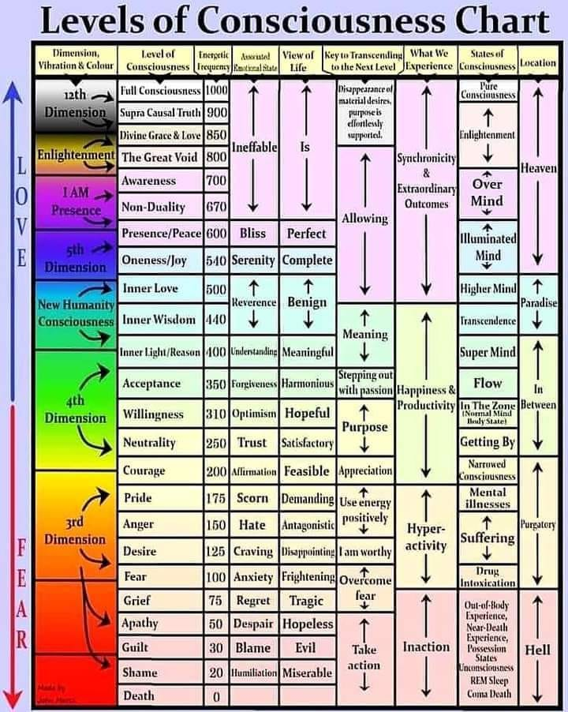
Where do you test for with
the Map of Scale of Consciousness?
Where are your levels of consciousness? Your awareness? There the number of people on the planet who calibrate at level 700 or more is increasing daily. We are waking up and seeing things that were hidden to us before. The Harmonic Convergence of 1987 when thousands gathered at Niagara Falls, helped the masses move above 200. David Hawkins wrote the book about this amazing way to understand your spiritual levels called "Power vs Force." Our Rose can test you for this during a Body, Mind & Soul Consultation during energy work or also called "applied kinesiology."
*A critical response point in the scale of consciousness calibrates at the level of 200, which is the level associated with integrity and courage. This is the balance point between weak and strong attractors, between negative and positive influence.
*At the levels below 200, the primary impetus is personal survival, although at the very bottom of the scale – the zone of hopelessness and depression – even this motive is lacking. The slightly higher levels of Fear and Anger are characterized by egocentric impulses arising from this drive of personal survival. At the level of Pride, the survival motive may expand to comprehend the survival of others as well. Approximately 85% of humanity resides below the consciousness level of 200. Humanity as a whole resides at the level of 207. As one crosses the demarcation line between negative and positive influence into Courage, the well-being of others becomes increasingly important. Arriving at the level of 500, the happiness of others emerges as the essential motivating force. The high 500’s are characterized by interest in spiritual awareness both for oneself and others, and by the 600’s, the good of mankind and the search for enlightenment are the primary goals. From 700 to 1,000, life is dedicated to the salvation of humanity.
*An individual’s level of consciousness is determined by the principles to which one is committed. To maintain progress in consciousness there can be no wavering from principle, or the individual will fall back to a lower level. Expediency is never an adequate justification. If it’s wrong to kill another human being, that principle can allow no exceptions, regardless of how emotionally appealing a rational may be used to justify the exception. Thus, a society that condones capital punishment will always have a problem with murder – both are products of the same level of perception. After all, to the murderer, the killing of the victim is a justifiable exception.
*Once a principle is breached, its mutated form propagates like a cancer. A society that supports killing – whether by war, by the police, or by the penal system – can’t at the same time effectively stop “criminal” killing. To kill is to kill is to kill; there’s no escaping that fact. The decision to kill or not to kill is a basic issue on the path to real power; but this rudimentary step hasn’t even been addressed by 85% of the world’s population or by virtually any of its governments.
*The more immediate “problem” of Right and Wrong that always diverts our societal focus only exists as a function of perception based at the lower levels of consciousness. Little children must be taught that dangerous behaviors are “wrong,” but as they grow older, discernment should replace moralism. Whether or not it’s wrong to kill other human beings may be a moral dilemma at lower levels of consciousness; at higher levels the very question is ridiculous. Conventional morality is therefore a provisional substitute for the faculty of higher consciousness. Moralism, a by-product of duality, becomes insignificant as the consciousness level rises through the 500’s, and is irrelevant at the level of 600.
*Merely to reach a stage where on functions primarily from Reason requires a major evolution in the consciousness to the 400’s, which is a very powerful level in world society – Freud, Einstein and Descartes calibrate at 499, the level of humanism. But reason, so vulnerable to loss of perspective through self-absorption, has in the long run never provided humanity with any solid moral, or even intellectual certainty. Again and again it has, to the contrary, led from the chaos of ignorance to an equally baffling convoluted cerebral maze. Any increased infusion of the influence of truth into the collective human consciousness gives us cause for greater hope than what tends inevitably to be a rather gloomy worldview.
*Although only 15% of the world’s population is above the critical consciousness level of 200, the collective power of that 15% has the weight to counterbalance the negativity of the remaining 85% of the world’s people. Because the scale of power advances logarithmically, a single avatar at the consciousness level of 1,000 can, in fact, totally counterbalance the collective negativity of all of humankind.
One Individual at level 700 | Counterbalances | 70 Million Individuals below level 200
One Individual at level 600 | Counterbalances | 10 Million Individuals below level 200
One Individual at level 500 | Counterbalances | 750,000 Individuals below level 200
One Individual at level 400 | Counterbalances | 400,000 Individuals below level 200
One Individual at level 300 | Counterbalances | 90,000 Individuals below level 200
Twelve Individuals at level 700 | Equals | One avatar at level 1000
*Were it not for these counterbalances, humankind would self-destruct out of the sheer mass of its unopposed negativity. Fortunately, the power difference between a loving thought and a negative thought is so enormous as to be beyond comprehension; even a few loving thoughts during the course of a day more than counterbalances all of our negative thoughts.
*To be operational, truth must not simply be “true,” but also knowable; yet each level of truth is unknowable to the levels below it and has no validity beyond its own territory. Thus we can conclude that all levels of truth as we know it – within the dimension of ordinary human functioning – are examples of dependent truth, whose veracity is totally contingent on a given set of parameters; i.e. it’s only true from your particular vantage point in this moment.
*Ignorance does not yield to attack, but dissipates in the light, and nothing dissolves dishonesty faster than the simple act of revealing the truth. The only way to enhance one’s power in the world is by increasing one’s integrity, understanding and capacity for compassion. If the diverse populations of humankind can be brought to this realization, the survival of human society and the happiness of its members are secure.
*The initial effect of taking responsibility for the truth of one’s life is to raise the lower energy levels to 200, which is the critical level that true power first appears and is the stepping-stone to all of the higher levels. The Courage to face truth leads eventually to Acceptance, where greater power arises at the level of 350. Here, there’s sufficient energy to solve the world’s problems. This, in turn, leads to the yet greater power available at 500, the level of Love. Knowing our own – and eveyone else’s – human foibles gives rise to forgiveness, and then to compassion. Compassion is the doorway to Grace, to the final realization of who we are and why we’re here, and to the ultimate Source of all existence.
___________________________________________________________________________________

Depression and the Holidays
Connecting to your Heart Center
|
There is a concept in Chinese Medicine called Shen. Your Shen resides in your heart, it can be described as the part of you which connects with your heart and spirit, or higher self. When Shen is depleted, we feel depressed and lack inspiration. It becomes hard to accomplish even simple tasks, because we don’t seem to care about anything. When your Shen is depleted, you feel disconnected from life, there may be an emptiness in your eyes, and a lack of peace in your life. You may suffer from sleep disturbances, patterns of stress, anxiety, or agitation. Imbalances of Shen can result in mental cloudiness, loss of memory and a lack of ability to maintain focus.
We connect with our Shen though our heart center. Think of the expression “follow your heart” verses being led by your logical mind. Our Shen gets depleted when we push ourselves to a point where we are just going through the motions of life. We deplete our Shen when we do not take time to go into our heart to rekindle our Spirit, connect with our Creator and quiet our mind. In addition, anything that “upsets the heart” can deplete Shen. Trauma, arguments, emotional struggles, or overuse of alcohol and drugs – even prescription drugs, if they cause you to feel disconnected from yourself.
In addition, you may notice the following:
Life feels off balance; your personality does not fit the life you are living.
There is a lack of inspiration and meaning to your life.
You feel like you have lost yourself, don’t know who you really are anymore. You have no sense of purpose.
You may have a lot of things going on around you, but you can’t find your center, so this leads to anxiety, restlessness, and eventually, fatigue.
You can no longer tell what is truly right for you.
Chinese Mood Elevator formula – is a combination of herbs traditionally used in Chinese medicine to help restore your connection with Shen to help increase vitality and promote a greater sense of well-being. This formula also helps to “calm the spirit and quiet the heart”. The herbs in this formula also work to gently cleanse the liver which helps to improve the flow of “Chi” (life force energy) throughout the body, which helps to lift the moods. The herbs in this formula promote healthy digestive functions, help the body to release pain and inflammation.

As your connection with Shen and the flow of Chi (life force energy) returns you will feel a shift in your perspective. It’s like the “birds are singing” again. Life begins to have more meaning and purpose, you feel whole, more complete. Your sleep is more restful. As you build your Shen you will focus more on the things that are important to you. You have a desire to align your life with your heart’s inner callings, you seek your Soul purpose. As you build your Shen your intuition activates, you have greater insights on your life choices and directions. Your eyes will have a brightness return to them and your mind will become clearer.
Blessings, Valerie (a fellow holistic practitioner)
I have used this excellent Nature’s Sunshine product to get me through a period this year of heavy grief, it can help with anxiety, depression, and many issues of the heart. I used Mood Elevator TCM, a concentrated version, taking less. Interested in ordering this? Make sure you are taking D3 also! 5000 IU’ daily, the main reason we suffer with the above. To order~ call them 1-800-223-8225 and tell them Body Glyphix (my acct # 9191) said to call, for my wholesale prices!! Rose

Yoga Nidra~ Meditation
Please join Yogini Rose for this VERY special mediation~ YN opens up doorways, releases blockages, it heals every organ, bone, muscle etc, it goes DEEP in to ALL levels of consciousness, releasing scars from traumas & abuses we have suffered from in this lifetime and more. Your YN takes you through the veils of life, afterlife, and previous lifetimes. We experience time travel, astral projection and it's also trippy! YN has an emphasis on health and healing where habitual thinking and thought patterns are reduced or eliminated. It also helps with insomnia and stress reduction and brings an incredible calmness, quietness, clarity and is one of the deepest of all meditations.

This meditation has a special emphasis on health and healing where habitual thinking and thought patterns are reduced or eliminated and it also helps with insomnia and stress reduction. It also brings an incredible calmness, quietness, clarity and is one of the deepest of all meditations. Yoga Nidra means Yogic Sleep and is a state of conscious Deep Sleep. In this Meditation, you remain in the Waking state of consciousness, and gently focus the mind, while allowing thought patterns, emotions, sensations, and images to arise and go on. However, in this meditation, you leave the Waking state, go past the Dreaming state, and go to Deep Sleep, yet remain awake. While Yoga Nidra is a state that is very relaxing, it is also used by Yogis to purify the Samskaras (negative energy & thought patterns). YN is also powerful tool for manifesting. It’s also great for insomniacs and those who suffer with PTSD. We will focus on New Years possibilities~ not resolutions or expectations.

The class is being held on Monday January 1st at 7:00 PM at our studio (click here for directions). The class lasts about 1 hour. The fee is $15 paid at the Studio or via snail mail. . On-line payments are $17~ due to processing fees. Pre-registration is a must. Should you reserve and are unable to attend- please let us know- for there is usually a cancellation/waiting list.
___________________________________________________________________________________
WINTER YOGA SCHEDULE
Times | Mon | Tue | Wed | Thu | Fri
9:30 am | Mystical  Vinyasa  Flow |  | Gentle Healing Yoga  Flow |  | Mystical Vinyasa  Flow
6:10 pm |  | Mystical Vinyasa  Flow |  | Mystical  Vinyasa  Flow

Mystical Vinyasa Flow A nice blend of Hatha & Integrative Yoga, Pilates, Somatics, fused with Reiki, blended with the wisdom of the cosmos & mysticism of Gaia ~ geared to participants needs
Gentle Healing Yoga Gentle, healing Yoga- Yoga Therapy, Somatics and Energy Medicine Yoga fused with Reiki, blended with blended with the wisdom of the cosmos & mysticism of Gaia ~
~ geared to participants needs
Yoga Nidra The deepest- most healing meditation on the planet- the 1st Monday of the month at 7:00 PM
Life Goes Om Free Yoga Classes to anyone with Cancer or a life threatening disease
Class Prices $15 drop in fee or punch card fees- 8 classes $95 or 16 classes for $165
Yoga for Sports Yoga for Golfers, Runners or Snow- Sports $85 per hour
Yoga Therapy, Chakra Toning or Private Yoga by appointment $85 per hour
“I would like my life to be a statement of love and compassion-and where it isn't,
that's where my work lies.” ~ Ram Dass

The Bodhi Glyphix Studio
Rose Czyrny
12377 Big Tree Road, East Aurora NY 14052
email: bodyglyp@msn.com
website: www.bodyglyphix.com
phone: 716.652.7805

