June 26th, 2024 Issue #222 The Iris The Bodhi Glyphix Studio

Greetings!

Thank You for allowing us into your world! Welcome to our monthly newsletter! Please feel free to share this via email or social media. If you no longer wish to receive to receive our newsletters, plz scroll down to the bottom and unsubscribe.
Welcome Summer! Astrologically & environmentally speaking, we have had quite a bit of action in our skies. Solar flare ups, retrogrades, high pollen counts and smoke from Canadian fires. Hoping that your respiratory tracks are not compromised and toxins/smoke didn’t affect your health. I had to be outdoors for the 3 days or so of air quality alerts. In the evening, my hair and nasal passages (when rinsed) the water was gray, of course I did a detox for a few weeks. If you would like my help, with a detox or to support your lungs, send me a message.
_______________________________________________________________________________________
OUR STUDIO WILL BE CLOSED
For a week and a well needed Staycation for Rose
Bodhi Glyphix will be closed Saturday June 29th through Sunday July 7th. Should you need supplements or any advice? Please reach out to me before then. Roll out your yoga mat, if you need your dose of Yoga. Do you need some structured yoga? I have a You Tube channel. It’s $15 to tune in and get your dose of Yoga. Here’s the link to 40 videos made during the pandemic. There are one or 2 with no sound. https://www.youtube.com/@roseczyrny
____________________________________________________________________________________________________________________
Attention Clients& Yoginis…
Beginning in September 1st….
With inflation out of control it is critical that we raise prices. Our Body, Mind & Soul Consultations are going up to $100 an hour. As you all know everything has been going up in price. In order to keep our doors open & give you my best, I will have to increase the price of consultations. Since Covid in 2020 we have been struggling to keep our doors open. Consultations are booked up pretty much through September too. Since I began accepting new clients this Spring, I have been extremely busy helping people. If you think staying healthy is expensive, you don’t want to find out how expensive care is with cancer, even minor health issues. Don’t forget to take your supplements, exercise/yoga, meditate and make those follow up appointments with me.
Yoga helps us heal on sooo many levels- Body, Mind & Soul. Did you know that- Anxiety and depression are undeniably different, but they’re also 2 sides of the same coin. Both conditions reflect a disconnect from the self, and they tend to arise when your body is trying to cope with unmanaged emotions like anger and grief. One of the many benefits of yoga is that it helps us reconnect and heal. Drop in some time, you will understand why its that fastest growing industry in the world.
Our drop in fee for yoga will remain $15. Our 8 pack will remain $95, the $16 pack will also stay the same at $165 for 16 classes. Never tried Yoga? Please- scroll down to the Yoga schedule down at the bottom of this newsletter. Join us some time!!
______________________________________________________________________________________
X39 The Holy Grail of Health

First~ please let me share my many stories. Many of you know I injured my knee pretty bad when I fell in Valu Hardware a few years ago. Well, I re-injured it again, and again... I put a patch right on my knee and within 24 hours it was better!! A year and half ago I hurt my back, blew out 5 disks, and rupturing three. Now, anytime I overdo it, or need a powerful healing modality, I cannot allow the studio to close~ I place one on a generic acupressure spot or directly on the area needing help, and it helps by making stem cells for rapid healing. My latest success story with these amazing patches, was on this past Monday 5/13 I suffered from a cornea chemical burn. My neighbor rushed me to an emergency appointment at Aurora Optical, they said they could help with a cornea burn. I was told it would take months for me to see out of my right eye. I used an X39 patch on an acupuncture point and placed an Aeon Patch on the eye glass lens of my right eye. Within 12 hours my sight returned in my eye!! Miracles do happen!!
I also have clients that could barely walk, spinal problems, knee issues etc. One woman did the patches for 4 months and was walking and swimming again. Another woman after many cervical spine surgeries and years of pain and inflammation, was able to come off her opiates and pain medications.
Now please let me tell you about these patches. LifeWave X39 is a patented phototherapy is designed to elevate a peptide known to enhance stem cell activity, clinically shown to elevate the naturally occurring copper peptide GHK-Cu, which is known to decline with age. When Copper HGK-Cu is elevated in the body, this peptide activates the bodies stem cells. This may provide incredible benefits such as:
⁕Rapid Pain Relief ⁕Mental Clarity
⁕Faster Recovery from Exercise ⁕Improved Sin Appearance
⁕Improved Energy & Vitality ⁕Supported Wound Healing
⁕Reduced Inflammation ⁕Better Sleep
How to wear them:
Place a new X39 patch 3 finger widths below your belly button, or on the GV14 acupressure point on the back of your neck. Locate by putting your chin into the hollow of your throat and you will notice 2 vertebrae protruding at the bottom of the neck. The GV 14 point is on the 2 vertebrae.
Wear the patch every day or night for 12 hours per day.Remove the patch for 12 hours, if left on too long your body can get used to the stimulation of the patch and begin to ignore it. All bodily functions work on cycles, just like the need for sleep. So to have the maximum effectiveness, there should be 12 hours of a ”rest” period. Should you forget and leave it on for 24 hours, remove the patch and wait at least 8 hours to start the daily usage again.
It is not necessary to put the patch directly on the pain or affected area~ but you may do so if you wish. Wearing it on the directed spots (below the navel or back of the neck) will positively affect the whole body. They do lose their efficiency after being worn on or near the body for more than 24 hours. Be sure to change them daily. They are also heat activated, so keep them away from heat, or do not carry them in a pocket.

How long before I see results?
Everyone is different. Some people get immediate results, but not everybody! Your body heals and regenerates on a priority basis. Your body knows what needs to be healed first, which you may not be aware of. Trust the natural healing order of the body. I like to suggest take a note book, jot dates and take notes so you can see your progress.
We recommend wearing them for 6 months even if you do not see an improvement right away. Stay consistent, most people notice ongoing improvement in health over time.

Some tips to help:
Stay Hydrated! Drink a large glass of water before applying the patch and continue to drink water through out the day. Take your body weight divide it by two, that is close to how many ounces you should drink daily, max is 90 ounces.
Mild Detox Symptoms~ it’s called a healing crisis. Symptoms of a headache, nausea or fatigue, drink plenty of water and the symptoms should go away. If they don’t, take the patch off and reapply it after 12 hours. Or try LifeWave’s Glutathione Patches to support the detox and decrease the detox symptoms.
Supplement with trace minerals in pink or gray sea salt, Nature’s Sunshine’s Mineral Chi Liquid works great too.

Eat Healthy meats and fats such as rainbow trout, salmon, sardines, whole eggs, coconut oil, full fat yogurt, walnuts, olives and grass-fed beef.

Eat More food rich in copper~ liver, oysters, kales, goat cheese, shitake mushrooms, chick peas, dark chocolate, sunflower and/or sesame seeds, almonds, cashews avocado and asparagus.

Take before and after photos, journal your days in a notebook, check out GHK-Cu Wikipedia page, do a google search, supplements and injections are not approved at this time.

You get 30 patches in the kit and…. Rose’s help with a purchase from the link or at the studio. If you order them yourself you can save $50, reach out to us for how to do this.
When you order form the link~ there is a 90-day hassle-free trial!
For first-time LifeWave customers we offer an Initial Order MBG money back guarantee. This policy makes it possible for new customers to try out products 100% risk-free and hassle-free for a full 90 days; no need to return empty sleeves or unused product. Only a customer’s first-ever order is eligible.
Not a first-time buyer?
You can still return resaleable product within 30 days of purchase date for a full refund..

To check out the patches or to order~ you may go to www.lifewwave.com/bodyglyp or message via email or check them out at the studio.
__________________________________________________________________________

The Skinny on Solar Flare Ups
We have been inundated with Solar Flareups during May. It is said it helps us raise our vibration and ascension. But boy o’ boy it can create chaos and much more. Intense solar flares can eject out huge amounts of solar material including radiation- called a coronal mass ejection (CME), which can fling out vast clouds of solar plasma away from the sun at speeds of up to 1 million mph. When aimed directly at Earth, the strongest solar flares and CMEs can interfere with communication systems, power stations and satellites.
If there is an explosion in the Sun, it may not come from a sunspot. Unstable magnetic filaments can pose the greater threat. Unstable solar filaments are twisted tubes of magnetism filled with dense plasma. These eruptions can hurl massive CMEs into space - and towards Earth if Earth-facing.
Solar flares are like cyclones or hurricanes on the Sun that emit intense amounts of energy, which can be directed towards Earth if Earth-facing at time of eruption. The Sun’s electromagnetic energy directly affects our body, mind and emotions. That’s because our bodies also emit electromagnetic frequencies, primarily from our heart and brain.
Solar flares and solar storms can affect us, especially people sensitive to energies. Symptoms may include chronic fatigue, aches and pains, tension headache, persistent head pressure, migraines, ringing in the ears, throat issues, toothaches, sore back, nausea, dizziness, itchiness, difficulty maintaining balance, feeling ‘spaced out’, becoming more aware, becoming aware of other dimensions, losing track of time, overwhelming emotions, agitation, restlessness, apprehension, anxiety, mood swings, feeling irritable, anger, depression, shaking, lethargy, tiredness, sleep disturbance / insomnia, vivid dreams, forgetfulness, feel ‘off’ or ‘foggy headed’, heart palpitations, short term memory issues and inability to concentrate. Also, one may experience trouble with wireless technology or may have inspiration coming forward at random times.
Solar storms are known to affect our pineal gland and desynchronise our circadian rhythm (our internal biological clock that controls our sleep and wake times). When solar winds interact with Earth’s electromagnetic field, it temporarily disturbs the magnetosphere. When Earth’s electromagnetic field is pushed and pulled by solar energy, our own electromagnetic field (our Auric field) senses the magnetic force and is also pushed and pulled. Solar flares affect our body’s Central Nervous System, all brain activity (including equilibrium), human behaviour and all psycho-physiological (mental-emotional-physical) response. At the DNA level, these solar flares are helping us awaken the hidden treasures within our dormant (galactic) DNA.
For those that are affected, you may find aromatherapy, sea salt baths or showers, drinking lots of water, reduce your caffeine intake, doing meditation and/or exercise as well as grounding to be of some help. Release negative energy. Ground yourself by walking in nature, meditating outdoors. Be gentle with yourself. Hydration and electrolytes are vital. Distance yourself from negative people.
During intensive energy shifts, it is highly recommended to regularly cleanse your energy field at the start and end of each day by meditating. Taking sea salt water baths or showers, eating light high vibrational foods, avoiding caffeine and alcohol, reducing the amount of time spent on technology, resting as much as you can, staying away from environments that feel toxic and draining, grounding yourself in nature, and when possible, spending periods of time alone.
_________________________________________________________________________________________________________________________
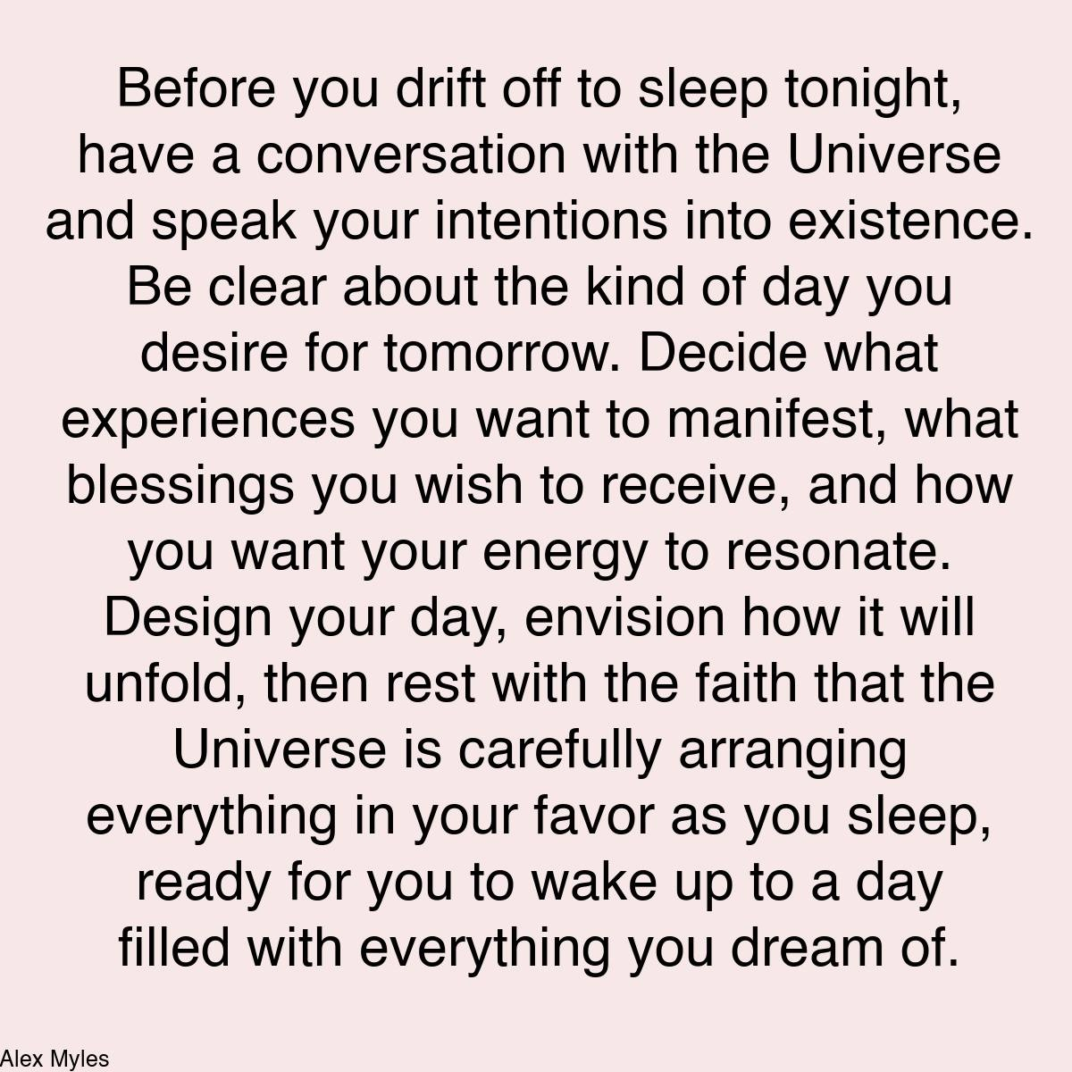
___________________________________________________________________________________________________________________________
Is Your Space Toxic?
THE TOXINS OF THE HOUSE ARE:
1. Objects You No Longer Use.
2. Clothes You Don't Like Or Haven't Used In A While. Damaged underwear.
3. Broken Things.
4. Old cards and notes.
5. Plants that are dead or sick.
6. Receipts and Old Magazines.
9. Shoes Broke.
7. Stuff of all kinds calling the past.
8. If you have children, toys that are not used, that do not work or broken.
WITH CLEANING THEM OUT:
1. Health gets better.
2. Creativity grows.
3. Relationships get better.
4. There is greater reasoning capacity.
5? Improved mood.
QUESTIONS THAT MIGHT HELP CLEANSING:
- Why am I saving that?
- Is it about me today?
- How will I feel if I release that?
Separate and classify:
1. To donate.
2. To throw.
3. To sell.
INSIDE CLEANING REFLECTED OUTSIDE.
1. Avoid extreme noises.
2. Less strong lights.
3. Less saturated colors.
4. Less chemical odors.
5. Less sad memories.
6. Finish unfinished projects.
7. Cultivate positive energy in your home.
Do a general cleaning and use boxes for organization. Start with drawers and cabinets and conclude each piece, do everything at your pace...
a) Trash.
b) Arrangements.
c) Recycling.
d) In doubt.
e) Gifts.
(f) Donation.
g) Sell.
As you CLEANSE, watch what changes in you.
As we clean our physical house, we also place order to our mind and heart.
Practice detachment with material things that just fill your space and you'll see how you'll slowly be able to do the same with more momentous situations.
Blessed be for you always
________________________________________________________________________________

Yoga Nidra Meditation
Monday
August 5th, 7:00PM
There will be no Yoga Nidra Meditation for July as our studio will be closed July 1st through the 8th. See you all in August for the most healing meditation ever. There’s plenty of room too! The next Yoga Nidra Meditation is Monday August 5th at 7PM.
Please join Yogini Rose for a very special yoga meditation class called Yoga Nidra. This is not your typical mediation~ YN opens up doorways, releases blockages, it heals every organ, bone, muscle etc, it goes DEEP in to ALL levels of consciousness, releasing scars from traumas & abuses we have suffered from in this lifetime and more. Your YN takes you through the veils of life, afterlife, and previous lifetimes. We experience time travel, astro projection and it's also trippy!
It is said that Yoga Nidra is the most healing and best of all meditations. It has an emphasis on health and healing where habitual thinking and thought patterns are reduced or eliminated and it also helps with insomnia and stress reduction. It also brings an incredible calmness, quietness, clarity and is one of the deepest of all meditations. Yoga Nidra means Yogic Sleep and is a state of conscious Deep Sleep. In this Meditation, you remain in the Waking state of consciousness, and gently focus the mind, while allowing thought patterns, emotions, sensations, and images to arise and go on.. While Yoga Nidra is a state that is very relaxing, it is also used by Yogis to purify the Samskaras (negative energy & thought patterns). It’s also great for insomniacs and those who suffer with PTSD, as well as a powerful tool for manifesting. It also raises “Bodhi” our awareness or spiritual growth.
Rose was trained to teach Yoga Nidra Meditation in Brazil during her Yoga Therapist Training. She has brought this powerful healing meditation to WNY in 2006. The fee is $17 on our website. Electronic processing fees have increased the payment amount here on our website. It's $15 cash or check. If you have a punch card at the studio, you may use it. Must be pre-punched, when you decide you would like to register. Pre-registration & pre-payment is a must- click safely below or snail mail it to us. This is a re-occurring class held the first Monday of the month. The class fills up quickly and the pay link button below will be removed when it is full.
ps....
you don't need a paypal account to sign up!
Should we fill up and you wish to be placed on our cancellation list for this Yoga Nidra~ please message us, as we get as we do get cancellations often.
Click on the link below to get in...
www.bodyglyphix.com/upcomingclassesevents/html

___________________________________________________________________
SUMMER YOGA SCHEDULE

Times | Mon | Tue | Wed | Thu | Fri | Sat
9:30 am | Mystical  Vinyasa  Flow |  | Gentle  Healing  Yoga |  | Mystical Vinyasa  Flow
6:10 pm |  | Mystical  Vinyasa  Flow |  | Mystical  Vinyasa  Flow

Mystical Vinyasa Flow A nice blend of Hatha & Integrative Yoga, Pilates, Somatics, fused with Reiki, blended with the wisdom of the cosmos & mysticism of Gaia ~ geared to participants needs
Gentle Healing Yoga Gentle, healing Yoga- Yoga Therapy, Somatics and Energy Medicine Yoga fused with Reiki, blended with blended with the wisdom of the cosmos & mysticism of Gaia ~ geared to participants needs
Yoga Nidra The deepest- most healing meditation on the planet- the 1st Monday of the month at 7:00 PM
Life Goes Om Free Yoga Classes to anyone with Cancer or a life threatening disease
Class Prices $15 drop in fee or punch card fees- 8 classes $95 or 16 classes for $165
Yoga for Sports Yoga for Golfers, Runners or Snow- Sports $95 per hour
Yoga Therapy, Chakra Toning or Private Yoga by appointment $95 per hour (click here for directions)

______________________________________________________________________________________

"Wishing you Heaven in your heart,
starlight in your soul and miracles in your life in these changing times”
The vibrational rate of our planet is quickening
Our bodies must make the vibrational change with the planet
Find down time, practice Yoga & Meditation

The Bodhi Glyphix Studio
Rose Czyrny
12377 Big Tree Road
East Aurora, NY 14052
email: bodyglyp@msn.com
website: www.bodyglyphix.com
716.652.7805

