**August 26th, 2024 Issue #224** **The Iris The Bodhi Glyphix Studio**

**Greetings!**Welcome to our free monthly newsletter. I hope this finds you healthy and happy.  We just about finished with a mercury retrograde, it is ending August 28th. But alas! We will be in the shadow of the retrograde until September 5th or so…. This means still can have issues for a week to ten day afterwards.

Here’s some great info to help us get through it.

**  
_______________________________________________________________________________________**We are Open on Labor Day

#### Yes, Yoginis~ There is Yoga Labor Day, Monday morning at 9:30 AM. Our classes are designed for beginner to intermediate students, I always say "do what we can in class and leave the rest." Whenever you come to class, please let me know if you have any physical issues, be it sinus congestion, bad knees, stressed out, back pain…. Whatever the pose is, I can put asanas into the class just for you without singling you out. For anyone thinking they may wish to try our yoga classes, yoi can drop in anytime! Drop in fee is $15 for an hour and 20 minutes or more of improving flexibility, strength, mobility, balance, strss reduction, clearing negative energy, hormone balancing, and much more! Let Rose know what is going on (any issues) and she can put the right poses into class to help you feel better! Did you know Rose put poses for the ****Pelvic Floor and Vagus Nerve**** in every class?? These two issues are coming mainstream to all doctors and healers. They do cause many health issues when not properly working. ****The Pelvic floor**** should have a dome shape, as we age that Dome shape flattens and drops down like a worn out trampoline. All of our organs sit on top of the pelvic floor. This causes issues such as urinary and fecal incontinence, painful intercourse, irritable bowel, rectoceles, prolapses, colitis, Crohn’s Disease, incomplete emptying of the bowels and bladder, intercostal cystitis, vulvodynia,  low back pain, and much more. We also hold truamas and stress in our PF, which tighten up the layers of our PF. Any type of abdominal surgery can cause pelvic floor issues.  Giving birth, low back pain, injuries, flat feet or high arches, feet pointing in or pointing out too far, sexual trauma, sitting a lot, crossing our legs too much, standing on a concrete floor, and eating spicy food or carbonated beverages are all contributors. Do you leak urine with intercourse, jumping or laughing? Any type of abdominal surgery will compromise the muscles of the pelvic floor. The removal of an organ will cause the organs above it to prolapse and put pressure on our pelvic floor. A hysterectomy full or partial or any organ even the small appendectomy will create a void and organs above it will fall down and create prolapses. If you need a hysterectomy or removal of an abdominal organ its wise to do PF therapy afterwards. Considering bladder surgery? Mesh ones have recalls on them. The surgery when they tack up your bladder doesn’t last,  they tack it up into an empty space, the prolapse can come back later. The pelvic floor was meant to move, today our sedentary lifestyles also contribute to pelvic floor issues. Lower estrogen during menopause allows the pelvic floor to get thin, and weaker. We all need Pelvic Floor exercises.   ****The Vagus Nerve**** work helps with anxiety, depression, stress management, inflammation, all gastrointestinal issues such as colitis, Crohn’s disease, irritable bowel disease, acid reflux, and anything that has to do with the gastrointestinal  track, blood pressure regulation, rheumatoid arthritis, diabetes, blood pressure, seizures, epilepsy, autism, Asperger’s syndrome, weight loss, erectile dysfunction, prostate issues, infertility problems, insomnia and they are discovering so much more! Working the Vagus nerve has been taught in Yoga for thousands of years. I have been training with some of the best, most knowledgeable experts in the world. Join us for a class and make a difference in your health. Scroll down for our Yoga Schedule. __________________________________________________________________________ When to drink water?

Many people say they don't like drinking water before going to bed so they don't have to get up in the middle of the night to go to the bathroom.

Why people have to pee so much at night.

When a person is sitting, the force of gravity holds water in their lower body.

This is why legs often tend to swell.

When you lie down, your lower body seeks balance with the kidneys.

Thus, the kidneys remove the water with the waste, because this is the most auspicious time.

Water is essential to remove waste from your body.

When the best time to drink water was.

It is necessary to drink water at the exact moments for its maximum effectiveness in the body.

2 glasses of water shortly after waking up activate internal organs.

1 glass of water 30 minutes before each meal improves digestion.

1 glass of water before taking a bath (or two) lowers blood pressure.

1 glass of water before bed prevents stroke or heart attack.

Drinking water before bed prevents leg cramps overnight.

When there are cramps, leg muscles go for water and moisture. I like to fill my tall glass (24 oz) 3-4 times a day, I count them. Hope you count your ounces too!   
_______________________________________________________________________________________  
 **MOXIBUSTION~ The Alternative to the Flu Shot  
Exclusively at our Studio**

**This year will be the 19th year we will be offering an "Alternative Flu Shot Remedy" which works with all strains of influenza.  It is a Chinese Homeopathic Application which was 99% effective last season with our customers.  The fee is $20 it takes 5 minutes at our studio and we discount families and groups greatly!**

**Influenzas**   
Morphs or changes every 13 days it’s called “drift”- so the medicinal flu shot derived from lasts years influenza- is totally ineffective! The Thimerosal in our medicinal flu shot is 49% Mercury, formaldehyde and other toxins. If you have had 5 consecutive flu shots in any decade your chance of getting Alzheimer’s disease is TEN TIMES HIGHER. This is partially due to the mercury and aluminum that is in every flu shot.  
  
**Moxibustion**Moxibustion is a traditional Chinese medicine technique that involves the burning of mugwort, a small, spongy herb, to facilitate healing. Moxibustion has been used throughout Asia for thousands of years; in fact, the actual Chinese character for acupuncture, translated literally, means "acupuncture-moxibustion." The purpose of moxibustion, as with most forms of traditional Chinese medicine, is to strengthen the blood, stimulate the flow of *qi*, and maintain general health.

**How does moxibustion work? Does it hurt?**There are two types of moxibustion: direct and indirect. In direct moxibustion, a small, cone-shaped amount of moxa is placed on top of an acupuncture point and burned. This type of moxibustion is further categorized into two types: scarring and non-scarring. With scarring moxibustion, the moxa is placed on a point, ignited, and allowed to remain onto the point until it burns out completely. This may lead to localized scarring, blisters and scarring after healing. With non-scarring moxibustion, the moxa is placed on the point and lit, but is extinguished or removed before it burns the skin. The patient will experience a pleasant heating sensation that penetrates deep into the skin, but should not experience any pain, blistering or scarring unless the moxa is left in place for too long.

**Indirect moxibustion** is currently the more popular form of care because there is a much lower risk of pain or burning. In indirect moxibustion, a practitioner lights one end of a moxa stick, roughly the shape and size of a cigar, and holds it close to the area being treated.

**Drift!** This effect happens when someone receives a influenza vaccination. They are injected with a live virus, which can give the injected person influenza. They are also spreading the influenza virus for up to 14 days, so anyone they come in contact with can get influenza!

**Shedding!** This is when one receives the influenza vaccination, they spread the virus for up to 14 days. They become carriers of influenza and spread the flu wherever they go. Avoid anyone who gets the flu shot, or pneumonia, shingles shots etc. Practice working on your immune, some great thoughts are below the info on moxibustion. 

**What is moxibustion used for?**

In traditional Chinese medicine, moxibustion is used on people who have a cold or stagnant condition. The burning of moxa is believed to expel cold and warm the meridians, which leads to smoother flow of blood and *qi*. In Western medicine, moxibustion has successfully been used to turn breech babies into a normal head-down position prior to childbirth. A landmark study published in the *Journal of the American Medical Association* in 1998 found that up to 75% of women suffering from breech presentations before childbirth had fetuses that rotated to the normal position after receiving moxibustion at an acupuncture point on the Bladder meridian. Other studies have shown that moxibustion increases the movement of the fetus in pregnant women, and may reduce the symptoms of menstrual cramps when used in conjunction with traditional acupuncture. Moxibustion is also used for many other purposes in conjunction with acupressure and acupuncture.

At our Studio we use *indirect moxibustion* (without needles) to simply warm the skin and the meridians directly responding to the immune. The technique is quick and virtually painless. We also recommend taking Vitamin D3 supplements, Silver Sol (we carry this priced way below suggested retail price), washing hands frequently and avoid touching your face.

Set up your appointment today.

652-7805 or email Rose

__________________________________________________________________________________  
 _______________________________________  
**Cold & Flu Prevention**

1 **Tap your thymus daily**! (Center of Chest)15 seconds (wakes up your immune)

1. **Vitamin D3** Nature’s Sunshine 2-3 daily (5-6000 IU’s daily) during cold months (7-10,000 for those with auto immune issues)
2. **Probiotic 11** Nature’s Sunshine’s 1 or 2….1st thing in the morning (good flora/bacteria to fight the bad).  
   4. **American Biotics or Nature’s Sunshine** **Silver Defense** When you feel flu-like symptoms coming on- pick up patented (proven to work against all viruses, fungi, bacterias, even MRSA & influenzas) listed way below retail – $24- exclusively at our Studio or the Gel $24 (use it as a natural hand sanitizer) Some folk stake a sm dose for maintenance.

5**. Exercise/Yoga/Walking**- key to staying healthy!  
6**. Sleep**- get enough 6-8 hours recommended for adults.

7. **Wash your hands** frequently!  
8.  **Do not touch your face or mucous membranes!**

9. **Lions Breath** daily & when you have been around someone who’s sick.

10. **Multi-Vitamin-** Super Supplemental or the Ultimate Green Zone Whole Foods Multi from Nature’s Sunshine

11. Consume only **Clean food, air & filtered water**

12. Eat **local organic foods**

13. Use **a Neti Pot** daily  
14. Nature's Sunshine Silver Shield or American Biotics Silver   
1 tsp as a preventative, it stops viruses from penetrating the cells!!! Use it full strength when fighting a bacterial or viral infection.    
For the Nature’s Sunshine Products~ to order at my wholesale price 1-800-223- them account number 9191 said to call or go to <https://www.naturessunshine.com/?referrer=9191>

Should you become sick- I am just a phone call or email away! I carry a great line of herbal helpers!!

|  |
| --- |
|  |
| **Inflammation & Stress You asked for it and here it is… Cannabis Butter For Recipes** **Brownies, Muffins, anything that uses butters or oils** |

## **It all began with my announcement of my using edibles for pain management (Lyme Disease)!!**

I have been asked to share my recipe to make cannibutter several times. As a Holistic Practitioner and certified Herbalist, I believe marijuana to be a medicinal herb. I have been suggesting its use for many health issues. Just as God put a flower, root and bark on our beautiful planet for us to heal from any issue. Here you go.... **Step 1**  
To make marijuana-infused butter like a pro, heat should be applied to the cannabis first to fully activate the THC, a process known as decarboxylation. To decarb your cannabis, heat oven to 240 degrees. Place the plant material in a single layer on a baking sheet with sides. Bake for 40 minutes, turning the sheet a couple of times to ensure even heating. The cannabis will become dry and crumbly. Now you are ready to add it to your butter or oil.  
**Step 2**  
In a medium saucepan bring a quart of water to a boil on the stove. You can vary the amounts, just be sure that the marijuana is always floating about 1 1/2 – 2 inches from the bottom of the pan. When the water is boiling place the butter in the saucepan and allow it to melt completely. My recipe uses 4 sticks of butter to every ounce of marijuana, so if you’re using a half ounce of cannabis that’s about 2 sticks of butter.  
**Step 3**  
Once the butter has melted you can add the marijuana. Once the cannabis is added the heat should be turned down, very low, to barely a simmer. I usually let the cannabis cook for around three hours. You can tell it’s done when the top of the mix turns from really watery to glossy and thick.  
 **Step 4**  
While the butter is cooking set up the bowl to hold the finished product. I like to use a heatproof bowl, and some people use a plastic food container. Place a double layer of cheesecloth over the top, and secure it with elastic, string or tape.  
**Step 5**  
Strain the marijuana butter over the bowl, carefully trying not to spill. When the saucepan is empty, undo the twine, pick up the cheesecloth from all four sides and squeeze out all of the remaining butter. I recommend gloves or some protection on your hands while your are squeezing it out, the THC can be absorbed through the skin on your hands and you might get a "contact buzz" which you may not have wanted at the moment. I enjoy micro dosing my edibles. As I do not use it to get high, I like to use it to help me relax from my busy days running a business by myself.  Put it in your refrigerator until you bake and create!!  
  
Anything you create should be micro-dosed until you figure out proper dosing. Start put with a small amount. The healing effects take 30-60 minutes to take effect. I like to freeze my pre-cut brownies!  And take a small piece out rather than having an alcohol beverage. Not to ruffle feathers, but alcohol is a product made by man, not our maker.  It is a spirit that invites negative spirits. It has no health benefits at all. And most of us feel the negative effects from drinking it the next day. The only negative thing about cannabis is it may increase your hunger for a few hours. I reach for treats that are healthy.   
  
I use the cannibutter to make unsweetened gluten free brownies using cacao and no sugar.  They are medi cinal, I am not concerned how they taste. I originally began making them with a store boughten gluten free brownie mix. I did not want sugar, so I have fine tuned a recipe off the internet where there is no sugar and rather than chocolate I use medicinal cacao.   
**Here are some possible health benefits of cacao powde**r that researchers are studying.. Keep in mind that you still need to be aware of the sugar and fat that are often in chocolate and cacao products. Also, as delicious as chocolate is, what matters most with your nutrition is your overall eating pattern, not any single food, as part of a healthy lifestyle.

Research is underway to see if cacao powder has a positive effect on irritable bowel syndrome.

**Lower Blood Pressure**

Cacao powder is packed with flavonoids. These nutrients have been shown to help lower blood pressure, improve blood flow to the brain and heart, and aid in preventing blood clots. The evidence for flavanol-rich cocoa products to lower blood pressure (compared to low-flavanol cocoa products) is of “moderate” quality, and the drop in blood pressure was small – but there were no side effects seen in short-term studies, according to a research review.

**Reduced Diabetes Risk**

The flavonoids in cacao powder may help increase insulin sensitivity, reducing your risk of diabetes, some small studies show. Larger studies are needed. Lowering your chances of developing diabetes also involves your overall diet and lifestyle – no single food is the answer.

**Reduced Heart Disease Risk**

In addition to antioxidants, cacao contains lots of potassium. Potassium has been shown to decrease the risk of heart disease by reducing lower body inflammation and stress on cells.

**Reduced Inflammation**

Some research suggests that flavanol-rich cacao powder may help to reduce inflammation. That’s in line with what antioxidants do. Whether that means that cocoa lowers the risk of conditions that are marked by chronic inflammation remains to be seen. Remember, all inflammation isn’t bad. Short-term inflammation is part of your body’s defense system.

**Less Stress**

If you’ve ever felt like having a little bit of chocolate improves your mood, you may be right. A preliminary study shows that eating dark chocolate (70% cacao) lowered chemical markers of stress. The mood benefits are more likely to be due to the good taste of cocoa products, rather than to specific nutrients, one report shows.

**Improved Cognitive Function?**

A specific flavanol in cacao called epicatechin may help with some parts of brain health, including cognition and blood flow. If so, that could lead to a lower risk of dementia. 

## **___________________________________________ Jewelweed ~Poison Ivy Antidote**

*Not only is this a tasty cold soup for summertime, it is a superior remedy for poison ivy rash.  
Sipping 2-4 cups of jewelweed broth, hot or cold, will quell both skin and joint inflammation.*

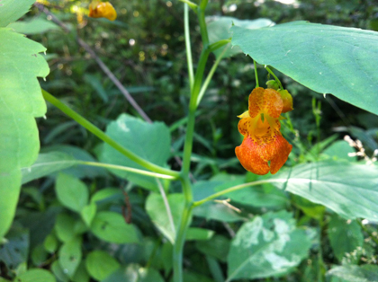

Harvest jewelweed (*Impatiens pallida* or *canadensis*) by pulling every 4th or 5th plant up by the roots. We are using the entire plant. The redder the root, the more effective this remedy.  
At home, rinse your jewelweed and place it, roots and all, in a pan, pressing it down very well.  
  
Add just enough cold water to barely cover the jewelweed and bring to a boil.  
Simmer, covered, until the water is orange.  
Cool, then refrigerate or pour into ice cube trays and freeze.

Jewelweed is the companion plant to poison ivy and can always be found within 25 feet of it. Should you brush against poison ivy- look for the antidote Jewelweed. Rub the leaves of the plant into the area subjected to the poison ivy. God put a remedy near every problem ….

*_____________________________________________________________________________________*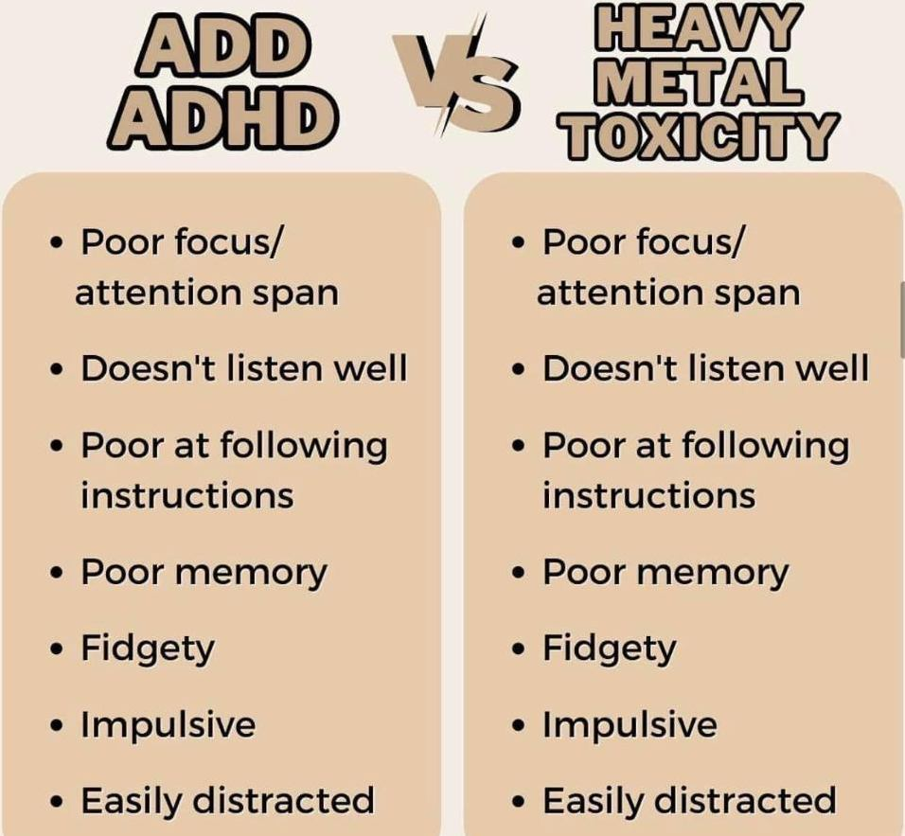

**ADD & ADHD Detox**Don't mask symptoms with medications, heal the body! Get the toxicity out and you will be amazed at what the body can do! We sell the best detox for heavy metals, chemical toxicity, mold, parasites and vaccinations her at our studio. The detox has been endorsed by the top functional doctors and naturaopaths. To take a look at the detox go to bodhi.thegoodinside.com and query the Zeolite Detox Pack. If you have done the cleanse before, I do the detox and support my liver when I feel like I have been exposed to any chemicals, molds, fungi, heavy metals and of course the smoke from the Canadian wildfires. This is also the detox suggested by the world known Dr Tenpenny for vaccinations. We only sell the best here at Bodhi Glyphix, if we sold you cheap imitations, products that didn’t work, loaded with fillers, heavy metals you would not recommend us or the product to anyone. We stand by anything we sell. Message us for your $50 off coupon and for the best directions on how to order and do the cleanse.   
**___________________________________________________________________________**

**The effects of Coffee on Iron Levels  
Are you iron anemic?**  
Medical FYI: Did you know that -- "A cup of coffee reduces iron absorption by 39 percent, and a cup of black tea will reduce it by 64 percent. Drip coffee will lower iron absorption by 72 percent, while doubling coffee's strength will reduce it 91 percent! In comparison, orange juice with its vitamin C, may increase iron absorption in a meal by 250%!" Am. J. of Clinical Nutrition 37:416-420,1983; ibid 32:2484-2489,1979

To prove this - Two patients went to give blood. Just before they left, they were told drinking liquid was important, so one drank 16 ounces of water and the other drank 16 ounces of tea. Needless to say, the Tea drinker was turned down to give blood due to a low iron count, due to the affects of the tea. A couple of days later, she was cleared to give blood.

I'm not saying drinking "tea" especially Herbal needs to be given up completely, but knowing that everything has timing and purpose, so drink water before blood tests for realistic results.

**__________________________________________________________________________  
Yoga Nidra Meditation**

# Please join me for a very special yoga meditation class called Yoga Nidra. This is not your typical mediation~ YN opens up doorways, releases blockages, it heals every organ, bone, muscle etc, it goes DEEP in to ALL levels of consciousness, releasing scars from traumas & abuses we have suffered from in this lifetime and more.  Your YN takes you through the veils of life, afterlife, and previous lifetimes.  We experience time travel, astro projection and it's also trippy! YN has an emphasis on health and healing where habitual thinking and thought patterns are reduced or eliminated. It also helps with insomnia and stress reduction and brings an incredible calmness, quietness, clarity and is one of the deepest of all meditations. Yoga Nidra means Yogic Sleep and is a state of conscious Deep Sleep. In this Meditation, you remain in the Waking state of consciousness, and gently focus the mind, while allowing thought patterns, emotions, sensations, and images to arise and go on. However, in this meditation, you leave the Waking state, go past the Dreaming state, and go to Deep Sleep, yet remain awake. While Yoga Nidra is a state that is very relaxing, it is also used by Yogis to purify the Samskaras (negative energy & thought patterns).  It’s also great for insomniacs and those who suffer with PTSD, as well as a powerful tool for manifesting. You will have the best sleep Monday night!!

The class is being held Monday, September 2nd at 7:00 PM~ we hold our Yoga Nidra Meditation the first Monday of the month. The fee is $15, pre-registration is a must. To pre-pay & register safely <http://www.bodyglyphix.com/upcomingclassesevents.html~> paying on line is $17 to cover our processing costs.  
**______________________________________________**

**SEPTEMBER YOGA SCHEDULE**

|  |  |  |  |  |  |
| --- | --- | --- | --- | --- | --- |
| **Times** | **Mon** | **Tue** | **Wed** | **Thu** | **Fri** |
| **9:30 am** | **Mystical  Vinyasa Flow** |  | **Gentle  Healing Yoga** |  | **Mystical Vinyasa Flow** |
| **6:10 pm** |  | **Mystical Vinyasa  Flow** |  | **Mystical  Vinyasa Flow** |  |

**Mystical Vinyasa Flow**  A nice blend of Hatha & Integrative Yoga, Pilates, Somatics, fused with Reiki, blended with the wisdom of the cosmos & mysticism of Gaia ~ geared to participants needs

**Gentle Healing Yoga** Gentle, healing Yoga- Yoga Therapy, Somatics and Energy Medicine Yoga fused with Reiki, blended with blended with the wisdom of the cosmos & mysticism of Gaia ~ geared to participants needs

**Yoga Nidra** The deepest- most healing meditation on the planet- the 1st Monday of the month at 7:00 PM

**Life Goes Om** Free Yoga Classes to anyone with Cancer or a life threatening disease **Class Prices** $15 drop in fee or punch card fees- 8 classes $95or 16 classes for $165  
**Private Yoga for Sports** Yoga for Golfers, Runners or Snow- Sports $85 per hour   
**Yoga Therapy, Chakra Toning or Private Yoga** by appointment$75 per hour "Wishing you Heaven in your heart, starlight in your soul and miracles in your life in these changing times”

**PROUDLY SERVING OUR COMMUNITY**  
**we're here to provide exceptional service**   
In alignment with our values here at Body Glyphix, we pride ourselves in offering an exceptional customer experience. Body Glyphix was established in 1984 by Rose and to this day is a heart-based business run by a female spiritual entrepreneur.

**Your Suggestions and input are encouraged- as always!**

The Bodhi Glyphix Studio

Rose Czyrny

12377 Big Tree Road, East Aurora, NY 14052

email: [bodyglyp@msn.com](mailto:bodyglyp@msn.com)

website: [www.bodyglyphix.com](http://www.bodyglyphix.com)

phone: 716.652.7805