December 23, 2024 Issue #228The Iris The Bodhi Glyphix Studio

Greetings!

Heart-felt Holiday Wishes from us to you and yours! With the Winter Solstice behind us~ we celebrate the return of our Sun!!! And much Gratitude for each and every one of you for your support this past year. Coming off of the Winter Solstice and heading into a time of root foods and root feelings, dig deep into your sub-conscious and let’s begin to think and live in the 5th dimension. It’s a place where you look at everything from the heart and our energetic bodies. These shifts have affected our DNA & RNA- we are entering the Age of Aquarius. The change is coming in like waves… Ride the waves, let’s be more like the water element as we bring in 2025.

Holiday Yoga Schedule

Welcome new Yoginis and old to any class, no need to call or email, just show up! Wear something comfortable, loose fitting. We have Yoga mats, you don’t need to bring one. Bring an open heart and mind. Be prepared to lose stress, anxiety, depression, tension and tightness from your body. Join Rose at any class and feel the healing power of Yoga. Drop in is $15 per class. Come as often or as little as your schedule permits. Scan down to the bottom for our schedule. We will be closed Monday 12/25 Monday 1/1/24.
_____________________________________________________________________________________
Inclement Weather~ Studio Closings
As we head into winter, living in Western NY often brings weather with hazardous travel conditions. When the weather is inclement, and you are wondering if we are closed, if our internet/phone is up and running, you will receive an email. If we do not have a phone/internet connection, check channel 7 and 2 for closing status. We would like you to be safe, when in doubt look for that email, or check Channel 7 or 2. Route 20A is kept clear, but look for our closing status, stay home and find the comfort in stillness, meditate or do some Yoga. Need that yoga fix? Check out my You Tube Channel and pay $15 with Paypal or next time you come to class, give your punch card a punch and skip doing paypal thing. Here's the pink to my paypal channel....
www.youtube@roseczyrny
_______________________________________________________________________________________
Snow Walking & Cold Water Immersion
(Snow Thermogenesis/Cryotherapy)
This healing modality can help you on soooo many levels! before you head out in the snow- have a bottle of warm water with you, a dry towel and shoes you may slip on when you have had enough. Here's some tips on walking in the snow:
So, how do I train for bare foot snow walking?
The most important thing to remember is that you are asking your body to adapt, so it will happen slowly and at your own body’s pace. Get your ego out of the picture, and decide to think of this as a long-term project.
The second thing to do is establish a regular outdoor cold walking schedule. For me, I take my dog out each morning and roll up my yoga pants and I do have a coat on. I attempt to stay out for about 2 to 10 minutes per session. If you are new, start with a minute or less. Breathe! Focus on your exhale. Allow yourself to feel the pain that comes with extremity training. When it hurts, go inside and warm your feet. You may use your hands or room-temperature water if you want. It’s not cheating.
Do this daily, and try to focus on your feet when they get cold. Focus on the pain, and don’t ignore it. We are learning to listen to our body. If your feet go numb while doing this, you have waited too long to go inside. Go in quickly and heat your feet up.
You are training the blood vessels in your feet to open and close more effectively.
After you have noticed progress in your cold endurance, pick an object or a tree or a place that you can see in your neighborhood and make that your goal. Walk all the way to the goal and back. Gauge how easy or hard that was and adjust the goal for next time. It is okay to reduce the distance if it was too painful. Over time, as your feet become more adapted, choose targets that are further away.
Have a safety bag. Cold Therapy trainers insist that you should always carry a safety bag along when doing outdoor cold exposures. Remember that when you do a snow walk, every step that you take away from safety is a step that you will have to take again when you decide to return. Sometimes we misjudge how far we can actually go. Rather than lose a toe, bring a bag with a towel (to wipe off the snow and dry your feet), and some easy to slip into shoes. Socks are nice, but if you are really in dire need of footwear, they may be hard to manage. I usually have slip-on shoes in my bag.
So, walk your own walk. You’ll get further on your own pace than if you tried to compete with someone else.
In conclusion, I am all for pushing our perceived limits and overcoming fear. However, please remember that there is no shame in being safe about it. Cold training and Wim Hof Method are doorways to a longer and healthier life. It’s not magic. It’s mastery of our physiology and psychology. And mastery takes time, focus, and a lot of patience. You’ll get there my friend. We all will. One healthy step at a time.
Some Benefits of Cold Therapy:
The Health benefits of barefoot walking in the snow inc:
1. Heightened Exhilaration
2. An increased sense of well being
3.Increased Circulation (for all circ/vascular issues)
4. Reduced Inflammation
5. Increased Immunity
6. Grounding
7. Helps the body make its own endocannabinoids
8. Helps with anxiety, depression & bipolarity
9. Increased their metabolism and improved their blood sugar response.
10. Helps the body produce T Cells, cancer fighters.
11. Releases oxytocin, DMT, Norepinephrine and other feel-good hormones.
12. The cold water makes brown fat, a less dense fat in the body. It does not tolerate white fat, so it pretty much consumes it, hence we lose weight and fat.

_______________________________________________________________________________________
Help with Cold & Flu Prevention!
If you have not had Moxibustion, you can still schedule an appointment with Rose. It takes less than 5 minutes. This can be done year round. Moxibustion is a remedy which uses a Chinese homeopathic called Artemis Vulgaris which is used to warm the skin at the meridian associated with the immune. It wards off all influenzas by working the immune. Our statistics / effectiveness for the past 19 years is nearly 100%. Be Pro-Active!!! One application lasts for a whole year.
My schedule for Moxibustion…
I am available by appointment Monday, Wednesday & Friday at 11 AM
Tuesday & Thursdays at 7:30 PM
1.Tap your thymus daily! (Center of Chest)15 seconds (strengthens your immune)
2 Nature’s Sunshine’s Vitamin D3 1-2xd Zinc 1-1xd Vitamin C T/R 1-1xd
3. Nature’s Sunshine’s Probiotic 11
4. Should you feel flu-like symptoms coming on- pick up patented (proven to rid the flu) Silver Biotics listed way below retail – $20- from our Studio or the Gel $20 (use it as a natural hand sanitizer)
5. Exercise/Yoga/Walking- key to staying healthy!
6. Get enough sleep 6-8 hours recommended for adults.
7. Wash your hands frequently!
8. Do not touch your face!
9. Lions Breath daily & when you have been around someone who’s sick.
10. Use a good Multi- Vitamin (Nature’s Sunshine Super Supplemental) organic, has minerals & aminos
11. Clean up your air & drink only filtered water.
12. Eat organic foods.
13. Use a Neti Pot daily.
And~ should you get sick- give me a call or send me an email.
There’s a natural remedy for EVERYTHING!!!
To purchase Nature’s Sunshine products at our wholesale cost call 1-800-223-8225 Tell them acct # 9191 said to call for my discount). Or click on https://www.naturessunshine.com?referrer=9191&offer=NSP
_______________________________________________________________________________________
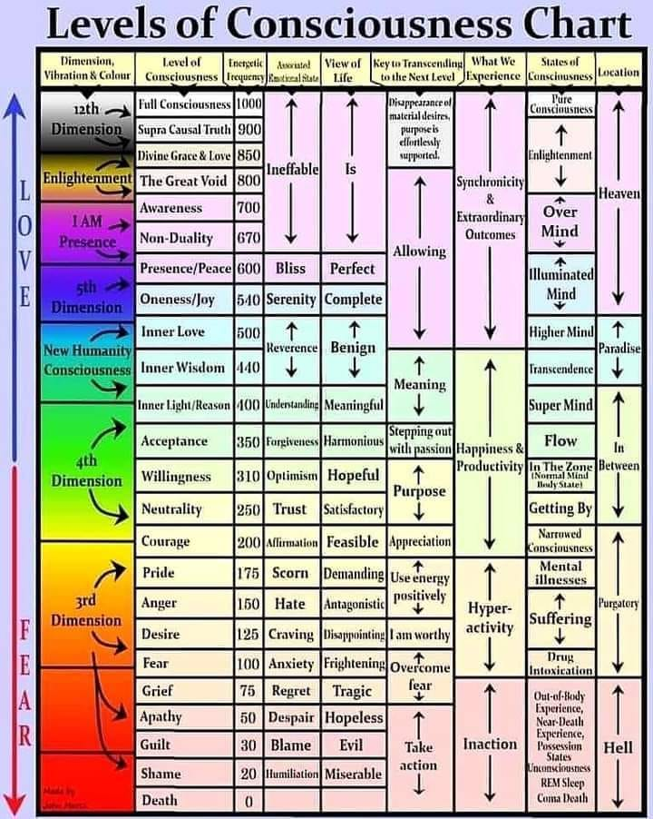
Where do you test for with the Map of Scale of Consciousness?
This is a gauge on your spiritual progress.
Where are your levels of consciousness? Your awareness? There the number of people on the planet who calibrate at level 700 or more and is increasing daily. We are waking up and seeing things that were hidden to us before. The Harmonic Convergence of 1987 when thousands gathered at Niagara Falls, helped the masses move above 200. David Hawkins wrote the book about this amazing way to understand your spiritual levels called "Power vs Force." I can test you for this during a Body, Mind & Soul Consultation during energy work or also called "applied kinesiology."
*A critical response point in the scale of consciousness calibrates at the level of 200, which is the level associated with integrity and courage. This is the balance point between weak and strong attractors, between negative and positive influence.
*At the levels below 200, the primary impetus is personal survival, although at the very bottom of the scale – the zone of hopelessness and depression – even this motive is lacking. The slightly higher levels of Fear and Anger are characterized by egocentric impulses arising from this drive of personal survival. At the level of Pride, the survival motive may expand to comprehend the survival of others as well. Approximately 85% of humanity resides below the consciousness level of 200. Humanity as a whole resides at the level of 207. As one crosses the demarcation line between negative and positive influence into Courage, the well-being of others becomes increasingly important. Arriving at the level of 500, the happiness of others emerges as the essential motivating force. The high 500’s are characterized by interest in spiritual awareness both for oneself and others, and by the 600’s, the good of mankind and the search for enlightenment are the primary goals. From 700 to 1,000, life is dedicated to the salvation of humanity.
One Individual at level 700 | Counterbalances | 70 Million Individuals below level 200
One Individual at level 600 | Counterbalances | 10 Million Individuals below level 200
One Individual at level 500 | Counterbalances | 750,000 Individuals below level 200
One Individual at level 400 | Counterbalances | 400,000 Individuals below level 200
One Individual at level 300 | Counterbalances | 90,000 Individuals below level 200
Twelve Individuals at level 700 | Equals | One avatar at level 1000
___________________________________________________________________________________

DMSO- the healing benefits of it have been supressed by big pharma
Open the link to read about the
benefits of DMSO and how to use it.
Best to buy it in a brown glass bottle and 99% purity.

https://articles.mercola.com/sites/articles/archive/2024/11/22/dmso-eyes-ears-nose-mouth-throat-health.aspx?ui=3a56a923075fd577c232bf87489d4f659ee48e6dfe86ca62a048baa2f7095c7a&sd=20111123&cid_source=dnl&cid_medium=email&cid_content=art1ReadMore&cid=20241122&foDate=true&mid=DM1662918&rid=168451487
The Healing Powers of Near-Infrared Saunas
I an excited to announce I am now a distributor for the best saunas on the market!! I wanted to purchase one forever and personally have been searching since 2015 on what type of sauna is the best and the most reasonable priced. Wet Saunas? Dry Saunas? Infrared?? Near Infrared?? Research shows- It’s red light near infrared that have the most benefits. Most saunas one needs to be in it for an hour for benefits, the near infrared is 20 minutes at the most. This led me to a company called Sauna Space this Spring 2024. I reviewed and researched their company and found they will sell the infrared heating element without the enclosure. I purchased the 4 bulb unit and had a friend hang it up in a closet the size of the tents they sell. The enclosures they sell block EMF's from getting into our bodies. The roof of my house is copper which blocks EMF's from coming into my house blocking the damaging EMFs. I purchased the unit to help me keep my Lyme disease in remission, help with sleep & take down inflammation. It heals mitochondria, & myelin sheath, and is detoxing. It has helped with all the above! A bonus I didnt expect- the sauna is burning fat! My body fat has dropped 4% since I began using it April 2024! It hasn’t budged for 20 years!! Read the below on the many benefits of this sauna. with my link you get another 10% off- or check out their products- if you have any questions- I am just an email away.
https://sauna.space/Bodhi

The Many Benefits of Near Infrared Saunas!!!
After almost 10 years of researching what sauna is the best- the jury is in!! It’s Near Infrared hands down!! Here’s the benefits of using it-
Live longer, happier and healthier! Frequent near infared sauna use has been associated with improved longevity, reduced risk of heart attack in the seminal 20-year Finnish male study by Laukkanen.
Reduced risk of stroke.
Reduced risk of dementia and AlAlzheimer’sisease.
Lowering of resting heart rate and reduced cardiovascular strain.
Reduced chance of heat stroke.
Improved endurance.
Faster recovery of muscles post exercise.
Increased production of Human Growth Hormone (HGH). HGH is essential basic muscle/tissue building; not to mention, maintaining high HGH levels is critical to prevent muscle atrophy and muscle loss associated with aging.
Increased Brain-Derived Neurotropic Factor (BDNF) in the nerve cells. BDNF, which has been called the “miracle grow of the brain”, is essential for proper nerve & brain functioning.
Reduced sensitivity to insulin. I think we all can appreciate what a problem insulin resistance plays in so many pathologies.
Reduced pain
Reduced inflammation
Accelerated wound & muscle healing
Amelioration of neuropathies
Improved recovery from stroke and traumatic brain injury (TBI)
Enhancement of athletic performance
Cognitive enhancement and neuroprotection
Restore functioning of old retinas
Restore eyesight
Burns Body Fat
Would you like to see their products? With my link I believe you get another 10% off- https://sauna.space/Bodhi
https://sauna.space/Bodhi

Yoga Nidra~ Meditation
There’s still Room for You
Please join Yogini Rose for this VERY special mediation~ YN opens up doorways, releases blockages, it heals every organ, bone, muscle etc, it goes DEEP in to ALL levels of consciousness, releasing scars from traumas & abuses we have suffered from in this lifetime and more. Your YN takes you through the veils of life, afterlife, and previous lifetimes. We experience time travel, astral projection and it's also trippy! YN has an emphasis on health and healing where habitual thinking and thought patterns are reduced or eliminated. It also helps with insomnia and stress reduction and brings an incredible calmness, quietness, clarity and is one of the deepest of all meditations.

This meditation has a special emphasis on health and healing where habitual thinking and thought patterns are reduced or eliminated and it also helps with insomnia, anxiety, depression and stress reduction. It also brings an incredible calmness, quietness, clarity and is one of the deepest and most healing of all meditations. Yoga Nidra means Yogic Sleep and is a state of conscious Deep Sleep. In this Meditation, you remain in the Waking state of consciousness, and gently focus the mind, while allowing thought patterns, emotions, sensations, and images to arise and go on. However, in this meditation, you leave the Waking state, go past the Dreaming state, and go to Deep Sleep, yet remain awake. While Yoga Nidra is a state that is very relaxing, it is also used by Yogis to purify the Samskaras (negative energy & thought patterns). YN is also powerful tool for manifesting. It’s also great for insomniacs and those who suffer with PTSD. We will focus on New Years possibilities~ not resolutions or expectations.

The class is being held on Monday January 6th^{t} at 7:00 PM at our studio. The class lasts about 1 hour. The fee is $15 paid at the Studio or via snail mail. On-line payments are $17~ due to processing fees. Pre-registration is a must. Should you reserve and are unable to attend- please let us know- for there is usually a cancellation/waiting list. If I cannot fill your spot- I am sorry you will have to lose your pre-payment.
___________________________________________________________________________________
WINTER YOGA SCHEDULE
Times | Mon | Tue | Wed | Thu | Fri
9:30 am | Mystical  Vinyasa  Flow |  | Gentle Healing Yoga  Flow |  | Mystical Vinyasa  Flow
6:10 pm |  | Mystical Vinyasa  Flow |  | Mystical  Vinyasa  Flow

Mystical Vinyasa Flow A nice blend of Hatha & Integrative Yoga, Pilates, Somatics, fused with Reiki, blended with the wisdom of the cosmos & mysticism of Gaia ~ geared to participants needs
Gentle Healing Yoga Gentle, healing Yoga- Yoga Therapy, Somatics and Energy Medicine Yoga fused with Reiki, blended with blended with the wisdom of the cosmos & mysticism of Gaia ~
~ geared to participants needs
Yoga Nidra The deepest- most healing meditation on the planet- the 1st Monday of the month at 7:00 PM
Life Goes Om Free Yoga Classes to anyone with Cancer or a life threatening disease
Class Prices $15 drop in fee or punch card fees- 8 classes $95 or 16 classes for $165
Yoga for Sports Yoga for Golfers, Runners or Snow- Sports $100 per hour
Yoga Therapy, Chakra Toning or Private Yoga by appointment $100 per hour
“I would like my life to be a statement of love and compassion-and where it isn't,
that's where my work lies.” ~ Ram Dass

The Bodhi Glyphix Studio
Rose Czyrny
12377 Big Tree Road, East Aurora NY 14052
email: bodyglyp@msn.com
website: www.bodyglyphix.com
phone: 716.652.7805

