May 26th, 2025 Issue #233 The Iris The Bodhi Glyphix Studio

Greetings!

Thank You for allowing us into your world! Welcome to our monthly newsletter! Please feel free to share this via email or social media. If you no longer wish to receive to receive our newsletters, plz scroll down to the bottom and unsubscribe.
______________________________________________________________________________________

Yes! There’s Yoga on Memorial Day Monday!!
Many of us have a three day weekend. There will be YOGA classes Monday morning at 9:30AM. Come and join us! If you have never taken a Yoga Class. You will learn asanas, mudras, pranayama (breathing) and the emotional and cosmic connection to yoga. Monday Morning’s Mystical Vinyasa Flow is geared towards beginner and intermediate level yoginis. Drop in fee is $15 for an hour and twenty minute session. We will honor veterans who have given their lives for our freedom in both classes. They may participate in Monday’s class for free.
______________________________________________________________________________________
Happy Father’s Day

To all of you Dads and women also- that have assumed the role of a Father. Many divorced or widowed women- assume the role and these masculine energies. Should you be looking for something different to give, or get- consider a gift of health with Yoga or a Body, Mind & Soul Consultation. We have gift certificates anytime, not just the Holidays. You may order one safely on our secure website www.bodyglyphix.com/giftcertificates.html or pick one up at the Studio.
_______________________________________________________________________________________

Do you have Environmental Sensitivities / Allergies?
Achoo! What’s bugging you??
I have been helping folks for many years get relief from environmental issues, pollens, mold spores, dander etc. First of all one must understand that just because you have allergy tests with a doctor that’s not necessarily the answer to finding What’s bugging you…. You may just have a sensitivity to things and one can order a sensitivity test to figure that out. It’s a hair strand test where you mail us pieces of your hair to accompany and they can tell you what triggers your sensitivities. See below for the link to unlock your environmental issues. Check the end of this article for info on the hair sensitivity test.

There are safe supplements rather than Benadryl and steroids to help ease your sesntivities and allergies. I like to Recommend Nature’s sunshine’s Histablock, it works great for alleviating symptoms. Its enzymes, all natural- that really works. To take down inflammation I like to suggest taking Yucca or Tart Cherry capsules. Heres a sample of the pollen alerts that I receive daily…..
This is an automatic allergen alert from the National Allergy Bureau, a service of the American Academy of Allergy, Asthma & Immunology.
Station: Olean
Pollen and Mold Summary
Tree: High
Weed: Not Present
Grass: Medium
Mold: Medium
Unidentified: Not Present
Top Species
Tree
Pine Family with air bladders
Oak
Willow
Maple, Box elder
Poplar, Cottonwood, Aspen
Alder
Juniper family, Cedar
Hemlock
Birch
Weed
None present
Grass
All identified grass pollen not counted elsewhere
Mold
Ascospores: includes Leptosphaeria, Venturia, Ascobolus, Diatrypaceae, Pleospora, Xylaria, Chaetomium, Sporomiella, Claviceps, Ascomycete, et al.
Cladosporium
Basidiospores: includes Coprinus, Agrocybe, Agaricus, Inocybe, Laccaria, Ganoderma, et al.
Any identified fungi not counted elsewhere
Smuts/Myxomycetes: includes Fuligo, grass smut, Urocystis, Ustilago, Tilletia, et al.
link to test for sensitivities with a hair sample
https://www.5strands.com/products/environmental-intolerance-test?variant=39842461778088&utm_source=Bing&utm_medium=PPC&utm_campaign=5S_USA_All_Standard%20Shopping_PT_PE&utm_content=Catch%20All&utm_term=pla-4588536905845415&wickedsource=google&wickedid=&wickedid=&wv=3.1&msclkid=e714d8588dd61e4d5cb4be63228e91c6
_______________________________________________________________________________________
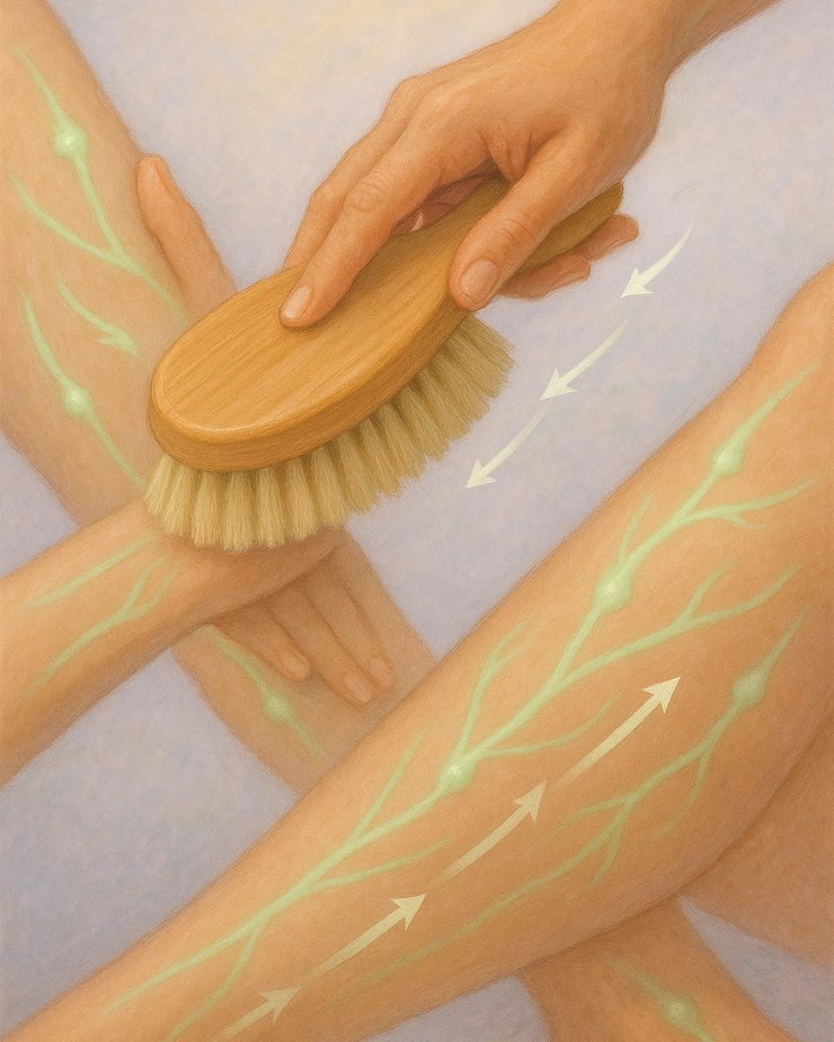
The Power of Dry Brushing: A Scientific Look at an Ancient Self-Care Practice
Dry brushing, also known as cutaneous brushing or skin brushing, is an age-old technique that involves using a firm-bristled brush on dry skin in specific strokes—often directed toward the heart. While it may appear simple, the physiological effects of dry brushing are profound, especially for your lymphatic system, skin health, and detoxification.
Let’s dive into the science-backed benefits of this beautiful ritual!
1. Stimulating the Lymphatic System

At the heart of dry brushing’s magic is its power to activate the lymphatic system, which helps:
• Drain excess fluid
• Remove toxins and waste
• Transport immune cells
• Support detox via lymph nodes
Dry brushing gently stimulates the superficial lymphatic capillaries under the skin, helping move stagnant lymph fluid and supporting detoxification.
Fun Fact: The lymphatic system has no pump like the heart. It relies on movement and stimulation (like dry brushing!) to flow effectively.
2. Enhancing Circulation & Skin Glow

Dry brushing boosts microcirculation, bringing fresh oxygen and nutrients to the skin while supporting cell regeneration and healing. It also:
• Increases blood flow
• Brightens the skin
• Promotes a youthful glow
Expect smoother, softer skin with regular brushing!
3. Supporting Detoxification Pathways

Your skin is a major detox organ! Dry brushing helps:
• Remove dead skin cells
• Unclog pores
• Activate sweat and oil glands
By clearing the way for your skin to “breathe,” dry brushing supports your body’s ability to eliminate waste naturally.
4. Stimulating the Nervous System

Brushing activates nerve endings in the skin, which sends signals to the brain. This enhances:
• Mental alertness
• Endorphin release
• A natural energy boost
It’s like a gentle wake-up call to your body!
5. Strengthening Skin Immunity

By improving skin turnover and barrier function, dry brushing supports:
• A healthy acid mantle (your skin’s protective film)
• Reduced transepidermal water loss
• Lower risk of skin irritation or infection
Organs That Indirectly Benefit from Dry Brushing

1. Liver: Less toxic load = better liver function
2. Kidneys: Easier filtration and metabolic balance
3. Gut: Supports fat absorption and immune modulation
4. Lungs: Reduces fluid congestion
5. Skin: Better tone, texture, and detox
How to Dry Brush Properly

• Use a natural bristle brush (avoid synthetic)
• Brush toward your heart in long, sweeping motions
• Start from feet → arms → abdomen → chest
• Avoid broken, sensitive, or inflamed areas
• Best done before showering, followed by hydrating oil or lotion
Conclusion
Dry brushing isn’t just a skincare ritual—it’s a cellular stimulant, immune supporter, and lymph-moving powerhouse. It’s a low-cost, time-friendly tool that enhances your circulatory, lymphatic, and nervous systems all at once.
So grab your brush, take a deep breath, and give your body the love and flow it deserves!

This article is for informational purposes only and is not a substitute for professional medical advice, diagnosis, or treatment. Always consult your healthcare provider before making changes to your health regimen.
______________________________________
Yoga Nidra Meditation
Theres still room!!

Please join Rose for a very special yoga meditation class called Yoga Nidra. This is not your typical mediation~ YN opens up doorways, releases blockages, it heals every organ, bone, muscle etc, it goes DEEP in to ALL levels of consciousness, releasing scars from traumas & abuses we have suffered from in this lifetime and more. Your YN takes you through the veils of life, afterlife, and previous lifetimes. We experience time travel, astro projection and it's also trippy! YN has an emphasis on health and healing where habitual thinking and thought patterns are reduced or eliminated. It also helps with insomnia and stress reduction and brings an incredible calmness, quietness, clarity and is one of the deepest of all meditations.
Yoga Nidra means Yogic Sleep and is a state of conscious Deep Sleep. In this Meditation, you remain in the Waking state of consciousness, and gently focus the mind, while allowing thought patterns, emotions, sensations, and images to arise and go on. However, in this meditation, you leave the Waking state, go past the Dreaming state, and go to Deep Sleep, yet remain awake. While Yoga Nidra is a state that is very relaxing, it is also used by Yogis to purify the Samskaras (negative energy & thought patterns). It’s also great for insomniacs and those who suffer with PTSD, as well as a powerful tool for manifesting. You will have the best sleep Monday night!!

The class is being held Monday, June 2nd at 7:00 PM~ we hold our Yoga Nidra Meditation the first Monday of the month. The fee is $15, pre-registration is a must. To pre-pay & register safely http://www.bodyglyphix.com/upcomingclassesevents.html~ paying on line is $17 to cover our processing costs.
_______________________________________
SUMMER YOGA SCHEDULE

Times | Mon | Tue | Wed | Thu | Fri
9:30 am | Mystical  Vinyasa  Flow |  | Gentle  Healing  Yoga |  | Mystical Vinyasa  Flow
6:10 pm |  | Mystical  Vinyasa  Flow |  | Mystical  Vinyasa  Flow

Mystical Vinyasa Flow A nice blend of Hatha & Integrative Yoga, Pilates, Somatics, fused with Reiki, blended with the wisdom of the cosmos & mysticism of Gaia ~ geared to participants needs
Gentle Healing Yoga Gentle, healing Yoga- Yoga Therapy, Somatics and Energy Medicine Yoga fused with Reiki, blended with blended with the wisdom of the cosmos & mysticism of Gaia ~ geared to participants needs
Yoga Nidra The deepest- most healing meditation on the planet- the 1st Monday of the month at 7:00 PM
Life Goes Om Free Yoga Classes to anyone with Cancer or a life threatening disease
Class Prices $15 drop in fee or punch card fees- 8 classes $95 or 16 classes for $165
Yoga for Sports Yoga for Golfers, Runners or Snow- Sports $95 per hour
Yoga Therapy, Chakra Toning or Private Yoga by appointment $95 per hour (click here for directions)
______________________________________________________________________________________

"Wishing you Heaven in your heart,
starlight in your soul and miracles in your life in these changing times”
The vibrational rate of our planet is quickening
Our bodies must make the vibrational change with the planet
Find down time, practice Yoga & Meditation

The Bodhi Glyphix Studio
Rose Czyrny
12377 Big Tree Road
East Aurora, NY 14052
email: bodyglyp@msn.com
website: www.bodyglyphix.com
716.652.7805

